KAPASA MAKASA UNIVERSITY


BEEKEEPING STUDY MODULE

Module Code: BS 102

First Edition
2023
Property of Zambia Forestry College

Copyright©
All rights reserved.
No part of this publication may be reproduced, stored in a retrieval system, or transmitted in any form or by any means, electronic, mechanical, photocopying, recording, or otherwise without prior written permission of the copyright owner.

Zambia Forestry College (ZFC)
P/Bag 1,
Mwekera,
Kitwe

© ZFC, 2025

TABLE OF CONTENTS
Executive Summary: 1
Acknowledgements 2
SECTION 1: IMPORTANCE OF BEEKEEPING 5
1.1 Introduction 5
1.2 Literature notes 5
1.3 Training Plan 7
SECTION 2: BEE BIOLOGY AND BEHAVIOUR 9
2.1 Introduction 9
2.2 Literature notes 9
2.3 Training plan 11
2.4 Hand Out: The Bee biology and behaviour 12
SECTION 3: BEE STINGS AND MANAGEMENT 19
3.1 Introduction 19
3.2 Literature notes 19
3.3 Training plan 21
3.4 Handout: Bee stings and how to manage them 21
SECTION 4: BEEKEEPING MENTOR SYSTEM AND BEEHIVES 24
4.1 Introduction 24
4.2 Literature notes 24
4.3 Training plan 24
4.4 Handout: Beekeeping Mentor system and beehives 25
SECTION 5: APIARY MANAGEMENT 30
5.1 Introduction 30
5.2 Literature notes 30
5.3 Training plan 32
5.4 Handout: Apiary Management 34
How to move the Bees into a beehive 36
SECTION 6: BEEKEEPING FLORAL CALENDAR 42
6.1 Introduction 42
6.2 Literature notes 42
6.3 Training plan 44
6.4 Handout: Beekeeping floral calendar 45
SECTION 8: HARVESTING QUALITY COMB HONEY 49
7.1 Introduction 49
7.2 Literature notes 49
7.3 Training plan 51
7.4 Handout: Harvesting of good quality comb honey 53
SECTION 8: BEEKEEPING EQUIPMENTS 59
8.1 Introduction 59
8.2 Literature notes 59
8.3 Training plan 61
8.4 Handout: Beekeeping equipment 62
SECTION 9: BEE PESTS, PREDATORS AND DISEASES 64
9.1 Introduction 64
9.2 Literature notes 64
9.3 Training plan 65
9.4 Handout: Bee Pests, Predators and Diseases 66

COMMON PESTS AND DISEASES IN ZAMBIA ..................................................... 0

SECTION 1: IMPORTANCE OF BEEKEEPING

1.1 Introduction
Beekeeping is not only a traditional practice but also a vital tool for forest conservation and sustainable livelihoods. In this session, the discussion will delve into the significance of beekeeping, exploring its role in preserving forests and its diverse array of products and services. Whether one is a seasoned bee farmer, an extension service provider, or simply someone interested in environmental conservation, this training will equip anyone with the knowledge and understanding to appreciate the value of beekeeping in our ecosystems. Through engaging discussions, brainstorming sessions, and interactive activities, the aim is to deepen participants’ appreciation for the interdependence between forests and bees, and empower them to contribute meaningfully to this essential endeavour.

1.2 Literature notes
Beekeeping, also known as apiculture, plays a crucial role in agricultural ecosystems and human societies worldwide. Beyond the production of honey, beekeeping offers a multitude of benefits that extend to environmental conservation, food security, economic development, and human health.
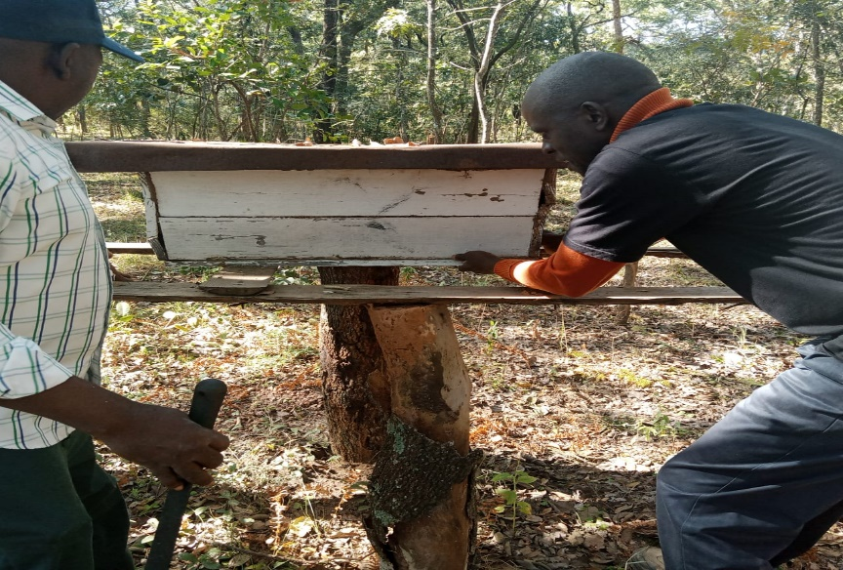
The main reason for keeping bees is to produce honey. Honey has value for its sweetening properties, as a food and as a fermentation agent for honey beer. It is also a readily tradable commodity and can realise cash or act as a bride price or a gift, for example. Honey is also becoming more marketable for its medicinal and cosmetic properties. Bees wax for example is a valuable by-product of honey production. It can locally be used for making candles, but it is often sold as a cash crop, since it has a relatively higher value on a weight-to-cash ratio and has an advantage of being non-perishable.

Fig. 1.1: A hive placed on a hive stand in the forest.
- Pollination Services:
From a global perspective, the greatest value of honeybees lies in their capacity for plant pollination. Keeping bees can increase the fruit and seed production of many crops and this is why some modern farmers keep bees themselves or pay beekeepers to put hives close to their fields. Pollen is increasingly being regarded as a product in its own right and can be harvested from hives with the aid of pollen traps. There is a specialist market for pollen in some food health outlets but its greatest value could be as a protein-rich food for local consumption. Propolis or bee glue, a um-like substance harvested by bees from trees and shrubs, is also finding its wider use. It is most often used locally, to mend leaking water containers for example, but growing awareness of its medicinal value and antibiotic properties means it is becoming a more marketable commodity
  - Bees are essential pollinators, facilitating the reproduction of flowering plants, including many crops consumed by humans. Through their foraging activities, bees transfer pollen between flowers, promoting fruit and seed production.
  - Approximately one-third of the world's food crops depend on pollination by bees, making them indispensable contributors to global food security and agricultural productivity.
- Biodiversity Conservation:
  - Beekeeping supports biodiversity by maintaining healthy populations of pollinators and flowering plants. By fostering habitats for bees, beekeepers contribute to the preservation of diverse ecosystems and the conservation of native plant species.
  - Bees play a vital role in maintaining ecosystem stability and resilience, influencing the reproduction and distribution of plants and supporting diverse wildlife populations.
- Economic Benefits:
The beekeeping industry contributes to the welfare of the individual beekeepers through the use and sale of the products. It also contributes to the wider rural economy, not only through the pollination of crops but also through trade. A profitable beekeeping enterprise has a knock-on effect to the wider community, including people who trade in bee products and those who make hives, smokers, protective clothing, honey packaging material, and so on. The value of the beekeeping industry varies from place to place, but in some cases it forms a significant part of the local or even national economy.
  - Honey production is a significant economic activity in many regions, providing income for beekeepers and supporting local economies. Bee products such as honey, beeswax, royal jelly, and propolis have commercial value and contribute to various industries, including food, cosmetics, and pharmaceuticals.
  - Additionally, beekeeping generates employment opportunities along the value chain, including hive management, honey extraction, packaging, marketing, and distribution.
- Environmental Sustainability:
Globally, Beekeeping is well known for its positive ecological consequences.
When more flowers are pollinated for example, more seeds (and eventually seedlings) will be produced. This increases the re-growth of numerous plant species and therefore, helps to protect against soil erosion.
  - Beekeeping practices promote sustainable land management and agriculture by encouraging the preservation of natural habitats and the adoption of bee-friendly farming practices.
  - Bees are sensitive indicators of environmental health, and their presence or absence can reflect the overall ecological balance and the impact of human activities on ecosystems.
- Human Health and Well-being:
  - Bee products, such as honey and propolis, have been used for centuries in traditional medicine for their therapeutic properties. Honey, in particular, is valued for its antibacterial, antioxidant, and wound-healing properties.
  - Beyond medicinal uses, beekeeping provides opportunities for recreational and educational activities, fostering connections between people and nature and promoting environmental awareness and stewardship.
Therefore, Beekeeping plays a multifaceted role in society, encompassing ecological, economic, and cultural dimensions. As stewards of pollinator health and biodiversity, beekeepers contribute to sustainable development goals and the well-being of communities worldwide. Recognizing the importance of beekeeping is essential for promoting policies and practices that support bee populations and the vital ecosystem services they provide.

1.3 Training Plan
Learning Objectives: By the end of the session, participants should be able to:
- Explain the diverse products and services associated with beekeeping.
- To use beekeeping as a tool for forest conservation.

Target Participants: Bee Farmers, Mentors, Extension Service Providers, District Officers, Producer Groups, and Individuals.
Suggested Number of Participants: A maximum of 30 participants is recommended for effective engagement between participants and trainers.
Duration: 2 hours. Materials
- Flip charts or chalkboard
- Notebooks and pens
- Bee products and flowers
- Posters
- TVs, Projectors, generators
- Films about bee products and services
- Handouts

Methods: Lectures, brainstorming and Group discussions
Step 1: Write the title "THE IMPORTANCE OF BEEKEEPING" on the flip chart or chalkboard and introduce it to the participants.
Step 2: Brainstorm with the participants on the link between forests and bees or their interdependence.
Step 3: Divide the participants into two groups and assign them the following tasks:
- Group 1: Why should your group be involved in beekeeping?
- Group 2: What bee products or services do you know, and what is their importance?
Step 4: During the plenary session, participants present their findings, and the facilitator clarifies, summarizes, and distributes handouts.

SECTION 2: BEE BIOLOGY AND BEHAVIOUR

2.1 Introduction
As you delve into the intricate world of beekeeping, it's crucial to grasp the fundamentals of bee biology and behavior to ensure successful hive management and optimize honey yields. Throughout this session, the aim is to equip learners with the essential knowledge and understanding required to navigate the complexities of bee colonies effectively. From identifying different bee castes to unraveling their roles and life cycles, the training endeavors to provide practical insights that will benefit beekeeping mentors, extension service providers, and dedicated farmers alike. With a blend of interactive learning methods such as group discussions, field exercises, and informative lectures, you anticipate an engaging and enriching experience for all participants.

2.2 Literature notes
Bees, belonging to the order Hymenoptera and the family Apidae, are remarkable insects known for their intricate biology and complex social behavior. Understanding the biology and behavior of bees is essential for effective beekeeping practices, pollination management, and ecosystem conservation efforts.
- Anatomy and Physiology:
    - Bees have three main body segments: the head, thorax, and abdomen. Their bodies are covered in dense hairs that aid in pollen collection and transportation.
    - Specialized structures such as compound eyes, antennae, and proboscis (tongue) facilitate sensory perception, communication, and feeding.
    - Female bees possess a unique anatomical feature called a pollen basket (corbicula) on their hind legs, used for carrying pollen back to the hive.
- Life Cycle:
  - The life cycle of bees consists of four stages: egg, larva, pupa, and adult.
  - Eggs are laid by the queen bee in individual cells within the hive's honeycomb. Larvae hatch from these eggs and are fed by worker bees with a mixture of pollen and nectar known as "bee bread."
  - Larvae undergo metamorphosis within sealed cells and emerge as adult bees. The development time varies among bee species and is influenced by environmental factors such as temperature and resource availability.
- Social Structure
  - Honeybee colonies exhibit complex social organization, with distinct roles assigned to different castes of bees: queen, workers, and drones.
  - The queen bee is responsible for egg-laying and colony reproduction. Worker bees perform various tasks such as nursing brood, foraging for food, building comb, and defending the hive.
  - Drones are male bees whose primary role is to mate with virgin queens. They do not engage in typical hive tasks and are expelled from the colony during periods of resource scarcity.
- Communication
  - Bees communicate through a variety of mechanisms, including pheromones, tactile signals, and dance language.
  - Pheromones play a crucial role in regulating colony behavior, coordinating tasks, and maintaining social cohesion.
  - The waggle dance, performed by forager bees returning to the hive, conveys information about the direction, distance, and quality of food sources.
- Foraging Behavior:
    - Forager bees collect pollen, nectar, water, and propolis (plant resins) from the surrounding environment to sustain the colony.
    - Bees exhibit flower constancy, preferring to visit flowers of the same species during foraging trips. This behavior enhances pollination efficiency and reduces competition among plants.
    - The ability of bees to navigate complex landscapes and communicate foraging information contributes to their role as efficient pollinators.
Conclusion: The biology and behavior of bees are intricately intertwined, shaping their role as vital pollinators, colony builders, and ecosystem engineers. By studying these fascinating insects, researchers, beekeepers, and conservationists can gain insights into the mechanisms underlying bee ecology and develop strategies to support bee populations and enhance ecosystem health.

2.3 Training Plan
- Learning objectives: By the end of the session, participants will able to:
Identify the three caste (types) of bees
State the roles played by the different caste (types) of bees in a bee colony
Explain the cycle of the different types of bees
- Target Participants: Extension Service Providers, Mentors, Beekeeping farmers and individuals
- Suggested Number of Participants: A maximum of 30 participants
- Duration: 2hours
- Materials: Flip Charts and masking tape or chalk board, pens, markers and books, pictures of bees and handouts.
- Methods: Lecture, Group discussion, Field Exercise to identify the different types of bees
Step 1: Write the title “Bee biology and behaviour” on the chalkboard or flipchart and introduce the topic to the participants.
Step 2: The participants to brainstorm on the meaning of the word bee biology and behaviour.
Step 3: Explain to the participant the meaning of bee biology
Step 4: Organise the participants in three groups and assign them the following tasks:
- Group 1: Discuss the roles the different caste of bees play in a bee colony
- Group 2: Describe the life cycle of different honey bee castes
- Group 3: Discuss the behaviour of the bee in different seasons of the year
Step 5: In plenary, participants present findings, the facilitator clarifies, summarizes and gives out the handouts.

2.4 HAND OUT: THE BEE BIOLOGY AND BEHAVIOUR
Honey bees live in a home of wax comb. These six-sided wax cells are very strong and house the brood (immature bees) during development and provide storage space for honey and pollen. In nature bees usually live in a sheltered cavity, such as a hollow tree or rock crevice. The colony is composed of a queen, drones, and workers.
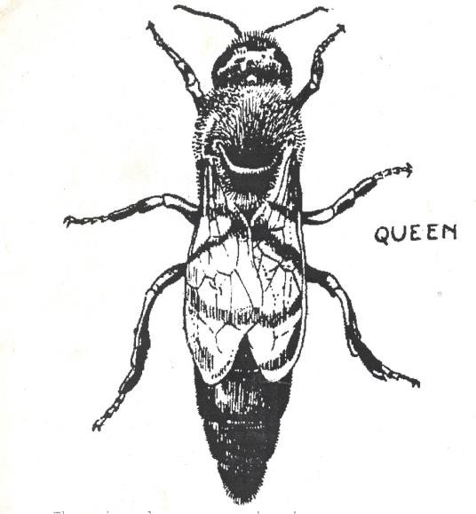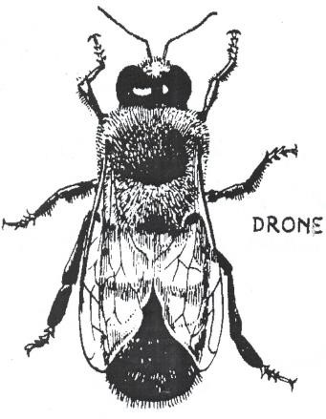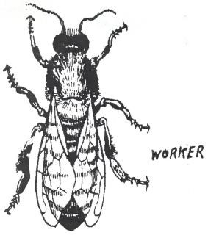
Fig 2.1 types of bees in a colony
The Queen
There is only one queen bee in the colony (family). As mother of the colony, her purpose in life is to lay eggs. She may lay several hundred eggs (approximately 2000) in one day. These eggs may hatch into drones (males), workers, or new queens. The queen can determine type of egg she is going to lay. She lays only the type that she feels the colony needs.
It takes sixteen days for queen to develop from an egg into an adult. About the seventh day after hatching, the queen flies from the hive and mates with one or more drones. This is the only time in her life that the queen mates, though she may live three to five years. When the queen mates with the drones, the sperms are deposited in special bag called spermatheca. Whenever the queen decides to lay the eggs, it will lay either the fertilized egg or unfertilized egg. To produce the worker bee, the egg from the ovary and the sperm from the drone which is in the spermathecal will mate. To produce a drone, the queen will lay only her unfertilized egg from the ovary.
The queen is larger than the worker and longer than the drone. Her wings are shorter in proportion to her body length than those of the drone or worker. She has a long tapering abdomen. When undisturbed, a mated, laying queen will usually be found on or near the comb containing the eggs in the hive.
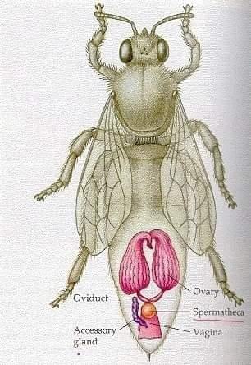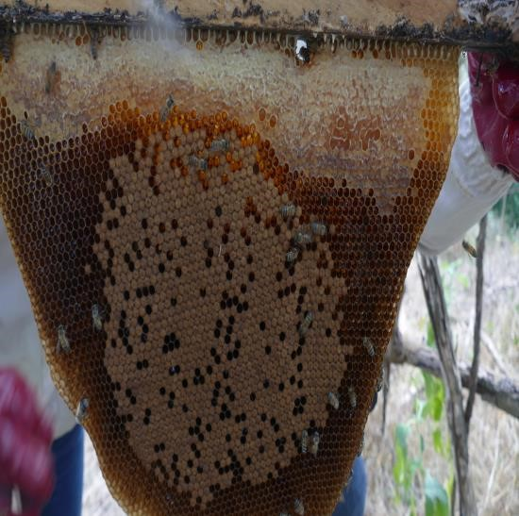
Fig 2.2: Left photo shows the reproductive parts of the queen. Right photo shows oval shape egg laying pattern of the queen. Only the queen lays eggs.
The Drone
The number of drone bees in a colony varies seasonally. There may be none when the bees have little food, but up to 1000 during the honey collecting season. When the honey season is over and food and water become scarce, the drones are expelled from the hive.
It takes 24 days for drone to develop from an egg into an adult. The drone does not work in the hive. The duty of the drone that is only male in the hive is to mate the queen and it dies after mating with her.
Drones are larger and fatter than the queen or the workers. Their bodies are not long as the queen’s. The drone has a short tongue he uses to take food from workers and from stored honey in the hive. He does not have legs fit to carry pollen and he is unable to produce wax. He has no stinger to defend himself.
The worker
There are 5,000 to 75,000 worker bees in a colony. They do the entire house and field work. Some workers go out of the hive to bring in water, pollen, nectar, and propolis (bee glue). Other workers remain in the hive to guard against the enemies. Still others clean the hive, build wax comb, nurse the young, and control the temperature of the hive. Workers eat honey to produce heat in cold weather and fan their wings to keep the hive cool in the hot weather.
It takes 21 days for a worker to grow from an egg into an adult. During the honey-collecting period, workers have special legs equipped with pollen baskets. They also have glands that produce wax and the scent necessary for carrying out their many duties. Workers are smaller than either the drones or the queen. They have the stinger which when it stings the stinger remains behind and it dies.

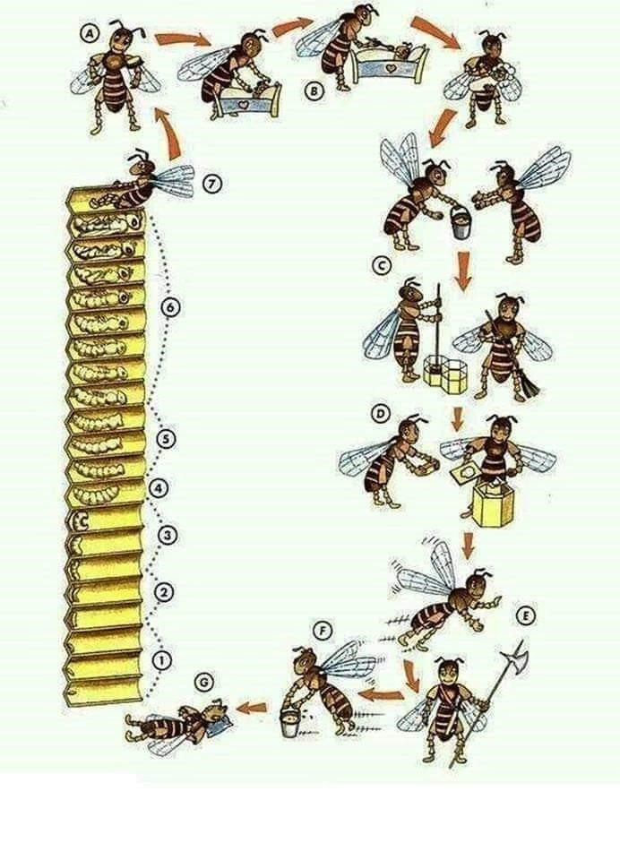
Fig 2.3: The worker bee does all work in the hive. The work is done according to age and keeps on transitioning. (A)Nursing the larvae (B) Feeding the larvae (C) Help in offloading and packing in cells, also cleaning of comb cells (D) construction of combs (E) Guarding (F) collecting nectar and pollen till death (G)

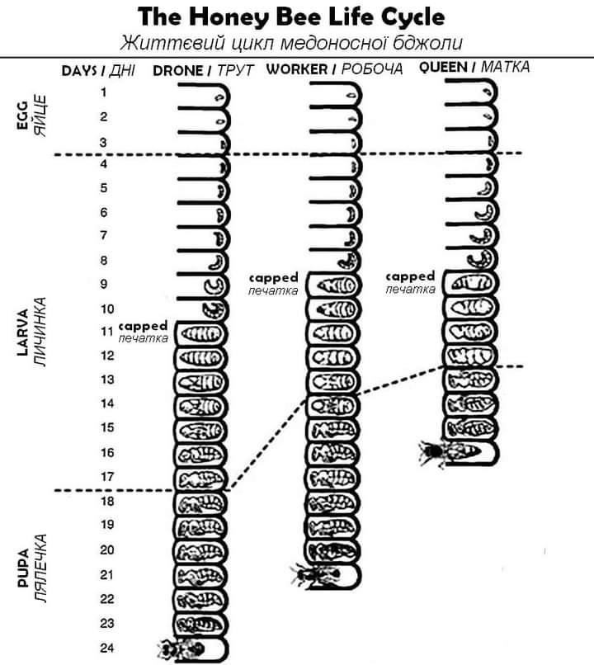
Fig 2.4: The life circle of a honey Bee
Growing bees have four basic cycles in their metamorphosis:
- EGG
- LARVA
- PUPA
- ADULT
During the development stage, the egg, larvae and pupae stages are known as brood. In the first three days, worker bees and queens have same growth process. The first day when the queen lays the egg, the egg will be upright, the second day the egg will be tilting and the third day the egg lies down at the bottom of the cell. Whether an egg will develop into a queen, drone or worker depends on the type of cell it is laid in and the food they are given. All larvae for the first three days are fed on royal jelly after which the larvae for the workers and drones are fed on pollen (bee bread). The queen continues to be fed on royal jelly throughout its life.
The table below shows that the larvae is capped at different days when they turn into pupae and later emerge as adult bees. The queen takes 16 days to be born and drone takes 24 days. The queen does not immediately start laying eggs but will wait for it to grow and develop the organs.
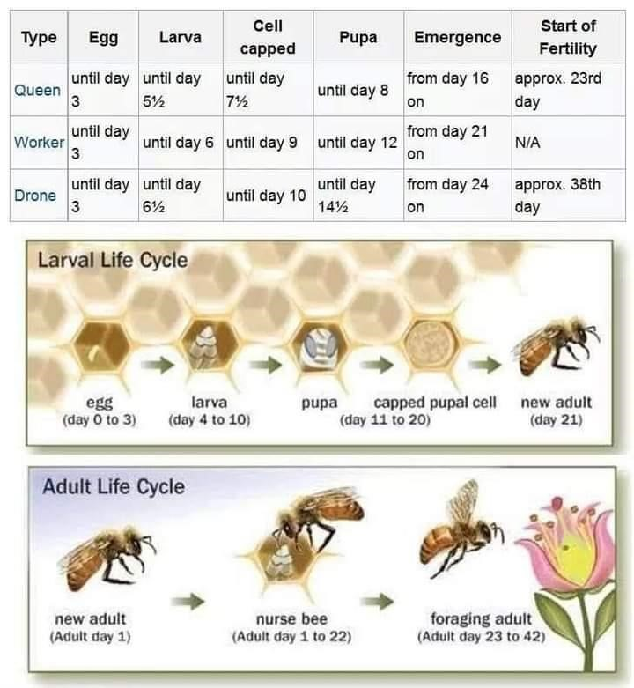
Fig 2.5: The life circle of a honey Bee
Communication in bees
The bees communicate with one another in several ways such as drumming feet, flapping wings like a ‘dance’ and use of pheromones (scents). The dance performed by the scout bees is one way the bees inform each other of the location of food and how far away it is. Bees have different types of dance that they perform to communicate to the other bees on the where the source of food is. If the food is near or less than 100m, the bee performs a dance known as “round dance” and if the food if very far, the bee will perform what is known as a “waggle dance”. The bees are able to decode from the dance of the bee the direction and distance of the food source.
The queen communicates with other bees through the “pheromone” it produces. It is the presence of this pheromone that makes them know that the queen is available. It also suppresses the worker bees from laying eggs while the queen is in the hive. This pheromone helps the colony to move as a unit when they are swarming. The pheromone also help attract the drones during the mating flight. Bees have different pheromones. For example when the bee stings, an alarm pheromone is raised among other bees who come to also attack the target.
Farmers are advised to smoke the stung area quickly to disguise the smell.

SECTION 3: BEE STINGS AND MANAGEMENT

3.1 Introduction
This section focusses on understanding, preventing, and managing bee stings which is a vital aspect of beekeeping and agricultural practices. As the session progresses, explore the fascinating world of bees, understanding their behavior and what triggers them to sting. Participants will be equipped with practical strategies to minimize the risk of bee stings, ensuring ones’ safety and the wellbeing of these essential pollinators. Further, the session will delve into effective ways to manage bee stings should they occur, enabling one with the knowledge needed to respond confidently and appropriately. It is not just about mitigating fears but fostering a deeper appreciation for the crucial role bees play in our ecosystem.

3.2 Literature notes
Introduction: Bee stings are a common occurrence for beekeepers and individuals who spend time outdoors in areas frequented by bees. Understanding the biology of bee stings, the potential health risks associated with them, and effective management strategies is essential for minimizing discomfort and preventing severe allergic reactions.
- Anatomy of a Bee Sting:
  - When a bee stings, it injects venom into the victim's skin through its stinger, which is a modified ovipositor found only in female bees.
  - The bee's venom contains a complex mixture of proteins, peptides, enzymes, and other compounds that elicit various physiological responses in humans, including pain, swelling, and inflammation.
- Health Risks:
  - For most people, bee stings result in localized pain, redness, and swelling at the site of the sting. These symptoms typically resolve within a few hours to a few days.
  - However, some individuals may experience more severe reactions, ranging from large local reactions characterized by extensive swelling to systemic allergic reactions known as anaphylaxis.
  - Anaphylaxis is a life-threatening condition that requires immediate medical attention and may manifest as difficulty breathing, rapid heartbeat, dizziness, and loss of consciousness.
- Management Strategies:
  - Prompt removal of the bee's stinger from the skin can help minimize venom injection and reduce the severity of the reaction. Scraping the stinger off with a fingernail or blunt object is recommended, as squeezing or pinching the stinger can release more venom.
  - Applying cold compresses or ice packs to the affected area can help alleviate pain and reduce swelling. Over-the-counter antihistamines and pain relievers may also provide symptomatic relief.
  - Individuals with a history of severe allergic reactions to bee stings should carry an epinephrine auto-injector (e.g., EpiPen) and seek immediate medical attention if stung.
  - Beekeepers can take preventive measures to minimize the risk of bee stings, such as wearing protective clothing (e.g., bee suits, gloves, and veils), using smoke to calm bees during hive inspections, and avoiding sudden movements that may provoke defensive behavior.
Therefore, Bee stings are an inherent risk associated with beekeeping and outdoor activities in bee-rich environments. While most bee stings result in mild to moderate reactions, severe allergic reactions can occur in susceptible individuals. By understanding the biology of bee stings and implementing appropriate management strategies, individuals can effectively mitigate the risks associated with bee encounters and ensure their safety and well-being.

3.3 Training plan
- Duration: 1 hour
- Learning objectives: By the end of the session, the participants must be able to:
Explain what make bees sting
Explain how to avoid bee stings
Describe how to manage the bee stings
- Target participants: Mentors, Bee farmers and producer groups who are interested to acquire more knowledge, farmers who fear bee stings
- Number of participants: Maximum 30 participants
- Methods: Lecture, Group discussion, Field Exercise to identify the different types of bees
Step 1: Write the title “Bee biology and behaviour” on the chalkboard or flipchart and introduce the topic to the participants.
Step 2: The participants to brainstorm on the meaning of the word bee biology and behaviour.
Step 3: Explain to the participant the meaning of bee biology
Step 4: Organise the participants in three groups and assign them to read the hand out and brainstorm the following:
- Group 1: Explain what make bees sting
- Group 2. Explain how to avoid bee stings
- Group 3. How to manage the bee stings
Step 5: In plenary, participants present findings, the facilitator clarifies, summarizes and gives out the handouts.

3.4 HANDOUT: BEE STINGS AND HOW TO MANAGE THEM
All the animals have ways of protecting themselves including the bee. The African bees are highly feared for their aggressiveness. Bees will only attack when you go to open the hive. All the mentors and farmers are advised to wear protective clothing as they visit the apiary and avoid doing things that irritates the bees. Mentors and bee farmers must be calm and smooth as they handle the bees.
As long as you work with the bees, they will be a time when you can receive the sting once in a while. Unless you are allergic and your reaction to bee sting is serious then you should not be near the bees or hive. While we all fear the bees, there are certain things we can do to avoid stings from bees.
What causes bees to sting?
- Disturbing them without smoke;
- Breathing into the hive, especially if the beekeeper has been drinking any alcoholic beverage, including beer;
- Wearing a cosmetic item which contains perfume
- Talking, drumming or making any other noise when bees are busy nearby;
- Standing in their flight path;
- Wearing dark clothes near the hive during the daytime;
Management of bee stings: Some of the symptoms of bee stings are:
- Urge to go to the toilet
- Increase in heart rate and breathing
- General weakness and the need to lie down
- Nausea and sickness
- Other experience rush or itchy body parts
Human body react differently when it is stung by bee. Other people will only experience what is known as a local reaction where by the swelling happen around the site where it has been stung. Others experience systemic reaction which means the whole body gets affected. They may have difficulties breathing and their heart rate may increase rapidly causing systemic reaction. How the body reacts depends on the number stings received and underlying conditions or comorbidities in the body. Like in advanced age or if the person is asthmatic or the immune system is weak, the person may experience what is known anaphylactic shock where the whole body reacts and the affected individual must be taken to hospital immediately.
But for normal stings, beekeeper are able handle them by using local materials so that the body does not swell. If you are working with the bees and you get stung, you must quickly smoke the body area where the bee stung you to hide the alarm scent that can alert other bees to attack. You can also remove the sting by pricking it out nicely with you nails or sharp object to avoid pumping venom into your body. The sting of the bee is barbed at the end. When it stings another insect the sting does not remain on the victim but whenever it stings animals with thick skin like humans, the sting remain and the bee dies afterwards as it is wounded on the abdomen.

Wherever the bee has stung the bee farmer, it has always been the farmer at fault and negligence to protect himself/ herself. The farmers are always advised to wear full protective clothing when they work with bees and to always carry a smoker.

SECTION 4: BEEKEEPING MENTOR SYSTEM AND BEEHIVES

4.1 Introduction
This section will explore the captivating realm of beekeeping, emphasizing the necessity of providing bees with suitable habitats and the pivotal role mentors play in guiding beekeeping endeavors. Beekeeping stands not only as a timehonored tradition but also as a vital component of sustainable agriculture and biodiversity preservation. By grasping the importance of adept hive management and mentorship, participants will glean valuable insights into nurturing thriving bee colonies while championing environmental stewardship. It's important to note that this training manual advocates against the use of bark hives due to their detrimental impact on trees, instead endorsing the use of wooden beehives.

4.2 Literature notes
As bees function as a familial unit, they require a home. Humans have devised a method of housing bees by providing them with beehives, serving as their abode. Top bar hives, characterized by elongated boxes containing multiple slats on top (top bars), are utilized. Bees are tasked with constructing a comb downward from each top bar. A typical beehive comprises 22 top bars and belongs to the "oldest" African technology known as "Kenyan Top Bar Hives." These hives are suspended high above 3 meters on trees using a pulley system and rope from the ground, thereby shielding them from bushfires and vandalism. To facilitate this, the beehives are equipped with metal hooks and robust wires. Elevating the beehive increases the likelihood of attracting bees to inhabit it. To construct, suspend, bait, and harvest from these beehives, it is imperative to enlist the expertise of an individual trained and specializing in beekeeping, commonly referred to as a mentor.

4.3 Training plan
- Learning objectives
Explain the importance of keeping bees into the beehive Explain what role the mentor plays?
State the importance of the beekeeping mentor system?
- Target Participants: District Management Team, Mentors, Beekeeping farmers and individuals
- Suggested Number of Participants: A maximum of 30 participants
- Duration: 2hrs
- Materials: Flip Charts and masking tape or chalk board, pens, markers and books, TVs, films and handouts.
- Methods: Lecture, Group discussion, and Field Exercise to see the beehives
Step 1: Visit hanged beehives in the field and allow discussion on various types of beehives and why people keep bees. Further let participants also discuss how best the beekeeping exercise can be organized in a community.
Step 2: welcome all participants back from the field visit. Ask the participants to state and or explain what they observed and leant from the field visit
Step 3: Write the title “Beekeeping Mentor Systems and beehives” on the chalkboard or flipchart and give a brief introduction/background
Step 4: Divide the participants in three groups and allow them to discuss the following
- Group 1: Why do people keep bees in the hives?
- Group 2: Explain why modern hives are different from the traditional hives in your area?
- Group 3: Describe who a mentor is and the role he/she plays in the group in terms of beekeeping activities?
Step 5: In plenary, participants present findings, the facilitator clarifies, summarizes and gives out the handouts.

4.4 HANDOUT: BEEKEEPING MENTOR SYSTEM AND BEEHIVES
Since bees live as a family, they need a home. Humans have found a way of keeping bees by providing a beehive which is a home for the bees instead of going into the forest to look for honey (wild honey gathering).
Top bar hives are long boxes carrying a number of slats on top (top bars). The bees are expected to build one comb down from each top bar. A good normal beehive has 22 top bars.
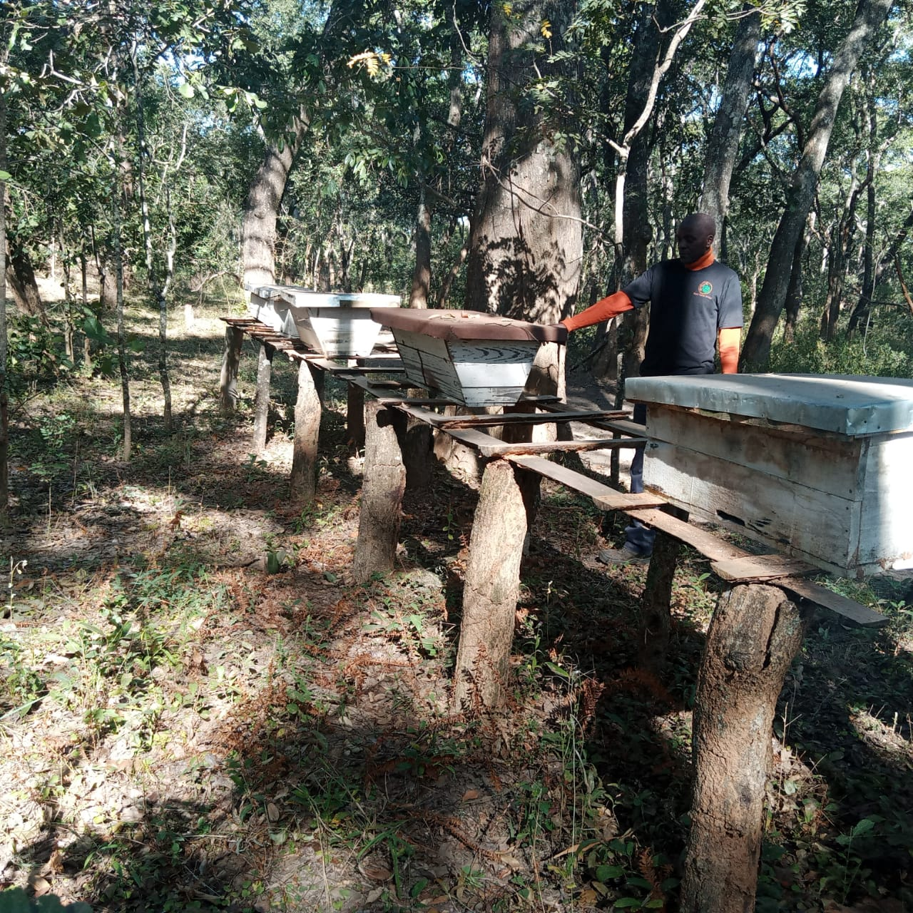
These beehives belong to the ‘oldest’ African technology called ‘Kenyan Top Bar Hives’. These beehives are hanged very high above 3m on trees using a pulley system and rope from the ground hence protecting them from bush fires and vandalism. To make this possible, these beehives come with metal hooks and strong wires. Hanging the beehive high increases chances of the beehive attracting bees to occupy it

Fig 4.1: A combination of Kenyan and Tanzanian beehives on the stand.
What are the advantages of the modern hives compared with traditional hives?
- The only exact measurements required in construction are those of the top bar itself. Other measurements are not too critical, so the hives can be made with simple tools from relatively cheap local materials.
- The size of the hive can vary to suit the local conditions.
- Every comb is accessible without removing the others. This one-bar-at-atime technique causes fewer disturbances to the colony and greatly reduces the number of bees flying around when the hive is open.
- The brood can be inspected easily, which gives the beekeeper real control over the management of the hive.
- The beekeeper can judge the exact time when combs are ready for honey harvesting without disturbing the brood. The honey is also of high quality as the combs can be selected to be free of pollen and brood which is good when selling quality honey.
- All top bars are at the same level, which can be chosen to suit the individual.
- If there are predators, hives can be suspended by wires above the ground at a height above 3m using rope and pulley system.
- The better management technique promoted by these hives help protect, preserve and increase the bee population. This then benefits the forests through increased income to farmers living around these forest through selling honey hence reducing charcoal production.
The hive itself consists of just six parts which the measurements that are not critical and hence construction and maintenance does not require highly skilled labour.
In the wild, bees develop their comb downwards in a gentle curve. Therefore, the sides of these hive need to be at an angle which approximates this curve. This limits the inclination of the bees to attach the comb to the side walls.
The top bars themselves do require critical measurements and uniformity. The bar must be 33mm wide. This is important as the tropical honey bee builds a comb which has a thickness of 25mm. The comb is attached to the center of the bar thus leaving a space of 3.5mm on each side. When two neighboring top bars develop combs the gap is 7mm (3.5mm + 3.5mm). This inner space (bee space) is vital to allow the bees to walk freely on the comb.
Measurement of the top bars: Length (d) = 50cm; Width (f) = exactly 33mm; Height (h) = 15mm to support heavy combs.
At the risk of repetition, the most significant is the width of the top bars, which must be kept at 33mm. If the space is less, the bees cannot pass through and they can seal it with propolis. If the space is wider, the bees may build combs on it. Therefore, the 33mm width must be adhered to.
Beehives are made from light, well-seasoned, good quality wood. The wood does not have a strong smell to affect the bees or honey. The parts of the hive are glued together with water-resistant glue before carefully assembling and nailing the hive. Below are the dimensions of the beehive body. If the mentor observe any problem to the beehive he must report so that maintenance to the beehive parts are done quickly. Quick maintenance can be done by mentor if the problem is minimal.
Dimensions of the body: Lid = 94cm X 52cm; Side = 26 X 87cm; Bottom 24cm X 90cm; ENDS (2):25cm in height, 42cm wide at the top and 20cm wide at the bottom
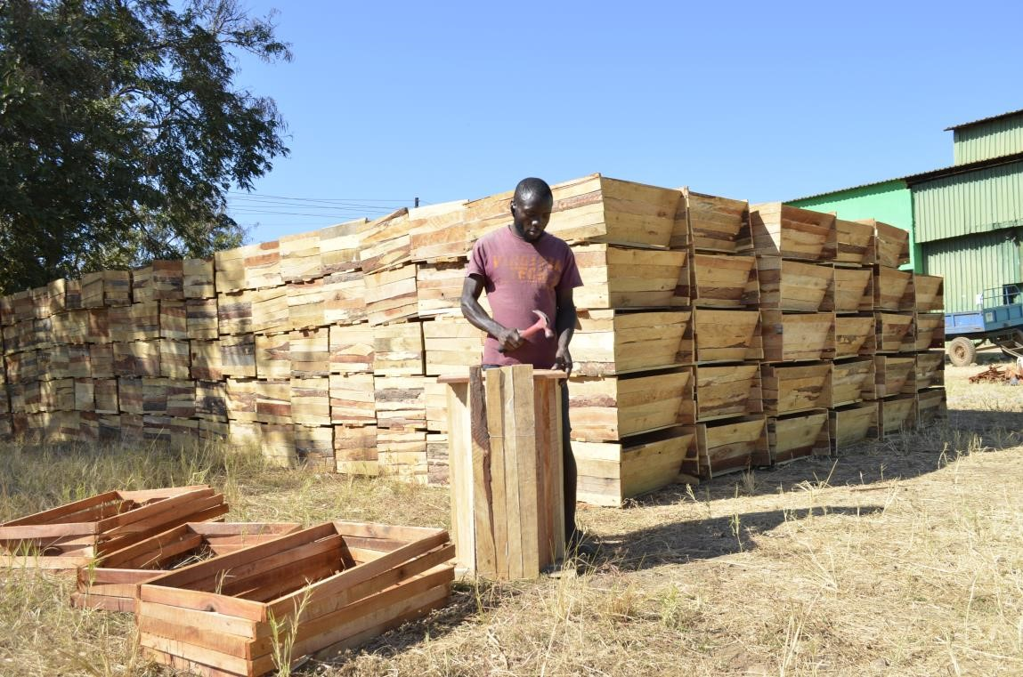
Fig 4.5: One role of the mentor is the assembling of the beehives.
Beehive lids
The lid protects the top bars underneath from the rains and water. A flat top lid can easily be made and repaired by the mentor. The beehives can either be covered with galvanized sheet metal or plastic, or any other water proof materials. Of all the types of material used on the lids, the plastic is the only one that can damaged quickly. We can prolong the life of the lids if we avoid putting the hives in the sun or any sharp objects falling on it. Mentors should also be careful at the time of harvesting when removing the lids that the wire should not prick it and when it is put away, the plastic must not face down or else twigs will destroy the plastic.
Who is a Mentor?
The MENTOR is an individual who resides in the chiefdom and has a proven interest and knowledge in bee-keeping. The mentor is selected by the Cooperative or group after being trained, examined, and proven capable. He will manage his/her particular chiefdom according to the following responsibilities:
Roles of Mentors
- assemble the bee hives and assist farmers in suspending them
- collect data and compile data in occupation of bee hives, damages of hives and harvesting results
- organize the distribution of buckets and harvesting inputs
- organize the harvesting in teams and supervise the harvesting of honey
- guarantee that the honey arrives at a bulking center for storage
- supervise harvesting teams and guarantee quality of honey
- Comply with organic standards; make sure all buckets have names of farmers, weight and origin indicated.
- Arrange meetings with hive owners for honey purchasing and organize other meetings if necessary.
Types pes of traditional hives:
- Clay pot hives
- Calabash hives
- Bark hives
- Mud hives
- Mat hive (from reeds)
- Uvutala hive (from bamboos)
- Kafukufuku hive (from grass and banana leaves)
- Log hives.

SECTION 5: APIARY MANAGEMENT

5.1 Introduction
This comprehensive session is designed to equip participants with the essential knowledge and skills needed to effectively manage beekeeping operations and promote thriving apiaries. Whether one is a seasoned beekeeper or just starting out, this training will provide valuable insights and hands-on experience to enhance ones’ beekeeping practices. Throughout this three-hour session, a range of topics essential to successful apiary management will be covered, and that is, from identifying optimal apiary sites to conducting hive inspections and maintaining meticulous records, each aspect of beekeeping will be explored in depth. Training methods combine interactive lectures, group discussions, and practical field exercises to ensure a dynamic and engaging learning experience. Participants will have the opportunity to collaborate with peers, share experiences, and learn from industry experts.

5.2 Literature notes
An apiary is any general area where one or more hives are kept and defines the area the hive owner is managing to increase the quality of bee habitat for increased honey production. All hives are marked with their specific identification number. Apiaries can be managed by one or more hive owners. Apiary management encompasses a range of practices aimed at maintaining healthy and productive honeybee colonies. Effective apiary management is essential for maximizing honey production, optimizing pollination services, and promoting bee health and well-being.
- Hive Placement:
    - Selecting an appropriate location for apiaries is crucial for bee health and productivity. Ideal locations offer ample forage resources, protection from harsh weather conditions, and minimal exposure to pesticides and other environmental hazards.
    - Considerations such as sun exposure, wind protection, and proximity to water sources should be taken into account when siting apiaries.
- Hive Equipment and Maintenance:
  - Beekeepers must invest in quality hive equipment and regularly inspect and maintain their hives to ensure optimal conditions for bee colonies.
  - Hive components such as frames, supers, and bottom boards should be cleaned and replaced as needed to prevent disease buildup and maintain hive hygiene.
  - Regular hive inspections allow beekeepers to monitor colony health, identify potential issues (e.g., pest infestations, disease outbreaks), and take appropriate remedial actions.
- Pest and Disease Management:
  - Effective pest and disease management strategies are critical for protecting bee colonies from common threats such as Varroa mites, small hive beetles, Nosema spp., and bacterial infections.
  - Integrated pest management (IPM) approaches that combine cultural, mechanical, biological, and chemical control methods are recommended to minimize reliance on synthetic pesticides and mitigate the development of pesticide resistance.
  - Monitoring for signs of pests and diseases, implementing hygiene practices (e.g., cleaning hive equipment, replacing old comb), and providing supplemental nutrition when necessary are key components of proactive hive management.
- Seasonal Hive Management:
  - Beekeeping practices vary seasonally, with different management tasks required during spring, summer, fall, and winter.
  - Spring and summer are periods of active colony growth and honey production, requiring frequent hive inspections, swarm prevention measures, and honey harvesting.
  - Fall and winter months are characterized by colony consolidation and preparation for colder weather. Beekeepers must ensure colonies have adequate food stores (e.g., honey reserves), protect against pests and diseases, and provide insulation to prevent cold stress.
- Record Keeping and Data Analysis:
    - Maintaining accurate records of hive observations, management activities, and productivity metrics (e.g., honey yields, colony strength) is essential for informed decision-making and continuous improvement.
    - Analyzing historical data enables beekeepers to identify trends, evaluate the efficacy of management interventions, and adjust practices as needed to optimize hive performance and profitability.
Apiary management is a multifaceted endeavor that requires careful planning, attention to detail, and ongoing education. By implementing best management practices, beekeepers can support thriving honeybee populations, enhance honey production, and contribute to sustainable agriculture and ecosystem health.

5.3 Training plan
- Learning objectives: By the end of the session, participants must be able to:
  - Identify a good apiary site
  - Demonstrate hive hanging
  - Demonstrate how to attract bees into the new hive
  - Demonstrate how to catch swarms
  - Explain how to keep clean the apiary
  - Conduct hive inspections
  - Keep good records
- Target Participant: District Management Team, Mentors, Beekeeping groups/farmers and individuals
- Suggested Number of Participants: A maximum of 30 participants • Duration: 3 hrs
- Materials: Flip Charts and masking tape or chalk board, pens, markers and books, beeswax (or propolis), beehive, protective clothing (veil, overall, gloves, etc.), pot/ tin for melting beeswax, and handouts.
- Methods: Lecture, brain storming, group discussion, field practical to bait the hives, hanging and hive inspections
Step1: Write the title “APIARY MANAGEMENT” on the chalkboard or flipchart and introduce it to the participants.
Step 2: Participants to brainstorm on how to choose a good location for the apiary
Step 3: Organise the participants into three groups and give them the following tasks:
- Group 1: Describe how to attract bees into the new hive and how to hang the hives
- Group 2: Describe catching a swarm of bees
- Group 3: Describe hive inspections and record keeping
Step 4: During plenary, the participants present the findings, the facilitator clarifies, summarizes and gives out the notes.
Step 5: Take participants for a field visit and do the following
- Choosing an Apiary Site: Take participants to a suitable location and demonstrate what makes it ideal for an apiary. Discuss factors such as proximity to water sources, availability of nectar and pollen, protection from harsh weather, and accessibility.
- Hive Hanging: Set up a demonstration hive and show participants how to properly hang a hive. Discuss the importance of hive orientation, ventilation, and stability.
- Attracting Bees and Swarm Catching: Set up another practical station where participants can observe techniques for attracting bees into a new hive using bait, pheromones, or other methods. Also, demonstrate how to safely catch a swarm of bees and transfer them into a hive.
- Apiary Maintenance: Show participants how to keep the apiary clean and organized to promote bee health and productivity. This includes removing debris, managing vegetation, and ensuring proper hive sanitation.
- Hive Inspections and Record Keeping: Set up a station where participants can practice conducting hive inspections. Demonstrate how to check for signs of disease, pests, and overall hive health. Discuss the importance of keeping detailed records of hive activity, including population size, honey production, and any issues encountered.
Step 6: Review and Wrap-Up: Gather participants for a final discussion and review of key concepts covered during the session. Encourage questions and address any remaining uncertainties. Distribute handouts summarizing the main points for participants to refer back to.
Step 7: Evaluation: Conduct a brief evaluation to gather feedback from participants about the session. Ask about what they found most useful, any areas where they still have questions, and suggestions for improvement. Use this feedback to refine future training sessions.

5.4 Handout: Apiary Management
An apiary is any general area where one or more hives are kept and defines the area the hive owner is managing to increase the quality of bee habitat for increased honey production. All hives are marked with their specific identification number. Apiaries can be managed by one or more hive owners.
Apiary siting
A good apiary is determined by the availability of the trees or flowers where the bees collect nectar and pollen and should be within 3km,and 500m from any source of water e.g. streams, rivers. For public safety, do not place you beehives near schools, clinics, busy road or any community dwelling to avoid the bees stinging the people.

Avoid locating apiaries near water-logged areas because the honey takes too long to reach 18% moisture content because of too much dew and the beehive can weather or wear out very quickly.
Do not place bee hives near agricultural areas where pesticides or other chemicals are used. Moreover, carefully observe agricultural activities near the apiary to observe if pesticides, chemicals or contaminants are being used. Such chemical could threaten bees and spoil the organic quality of the honey. It is recommended that no pesticide, fertilizer, or chemicals should be used at least 3 km from the apiary.
The apiary must have good air drainage (good air circulation). This means it must have a good airflow. The hives must be protected from strong wind, which may cause drifting of bees and swinging of the hives which are hanged high. It must also be protected from hot sun by providing a partial shade. To protect the hives from ants and termites, no weeds must be allowed to grow around the hive as they form the bridge for the ants to reach the hive. The scent from weeding usually upset the bees; hence the apiary must be well prepared in advance. During dry spell, a firebreak can be made around the apiary to prevent the hives from being burnt. The apiary must be kept clean and tidy all the time. Suspension of the beehives
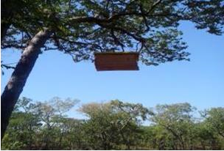
Fig 5.1: The picture on the left shows the suspended hive above 3m.
It is advisable that all hives must be hanged 3-5 meters above the ground. This is done by using the pulleys and the rope to suspend them very high. The mentors will assist the farmers in the hanging of the hives. When hanging the hive observe the height which should be 3m above, distances between hives must be a minimum of 20m, and only one hive per tree.
The advantage of hanging of the hives very high is that it increases the occupation of the hives. It also removes threats of attacks from honey badgers and reduces risks from fire and theft of honey.
During the harvesting season, the hive must be brought down using a pulley and rope. The harvesting must be done by two or three people (mentor, Beekeeping Lead farmer, and farmer - hive owner. The team will be given protective clothings (veil, overall, gloves, gumboots), smoker.

How to move the Bees into a beehive?
- Beehive preparation
  - You can prepare the hive so that the bees can accept it by rubbing either of the following substance (or a mixture of both) on the inside of the hive: Beeswax and propolis.
  - The most available is beeswax! Before using them, you must soften beeswax on fire in a pot or a tin.
- Making a wax foundation on the top bar
  - Top bars should be made from high quality wood and they must be made very carefully so that they fit exactly into the hive.
  - You have to put a starter strip along the middle line of every top bar otherwise the bees would have no line for starting the combs.
  - You have to apply on the middle of the top bars, you must expose them together with clean beeswax to the fire and make it molten.
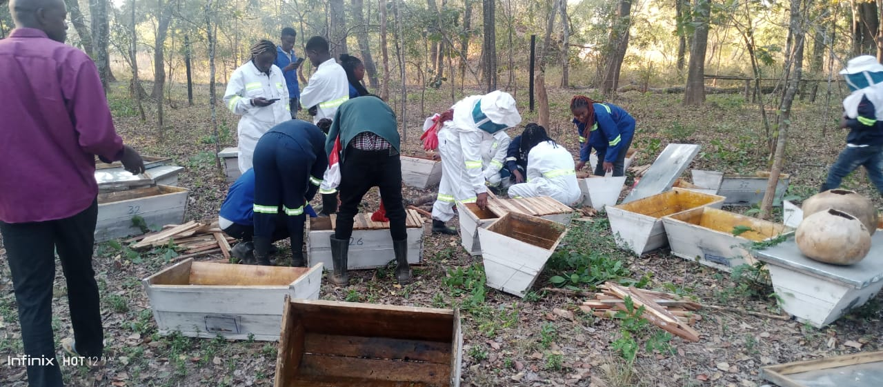

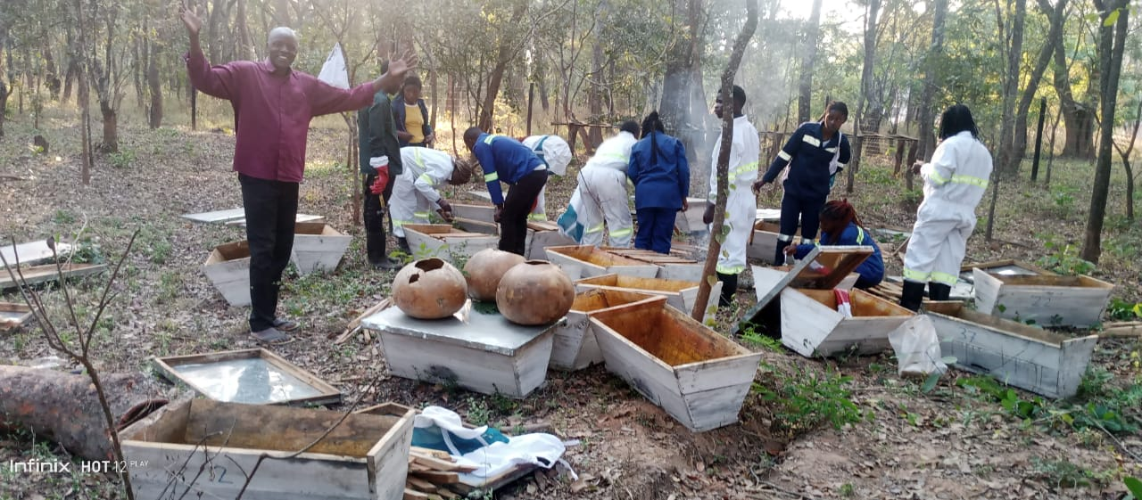

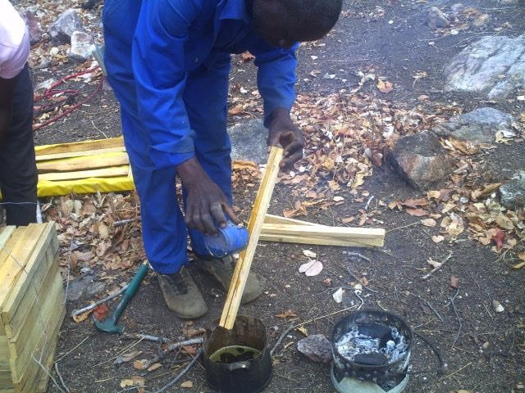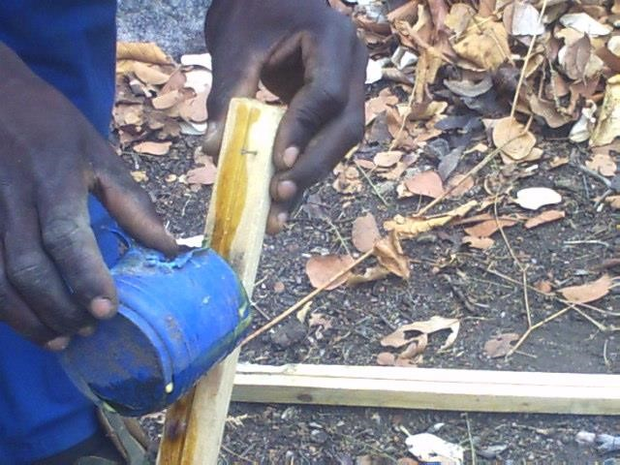
Fig 5.2: Melt clean beeswax in a pot or tin pot. Apply melted wax following the line in the middle. Make the foundation thick about 1cm. The bees will follow this straight line to make combs. Apply to the 22 total number of top bars on the box.

3. Wax application on the top bars
Applying wax incorrectly to the top bars in beehives can have several negative effects on the hive and the bees:
- Foundation for Comb Building: Bees use the wax on the top bars as a foundation for building honeycomb. If the wax is applied incorrectly or unevenly, it can hinder the bees' ability to construct straight and uniform comb. Crooked or uneven comb can make hive inspections more difficult and can reduce the efficiency of the hive.
- Stress on Bees: Bees rely on precise measurements and alignments when constructing honeycomb. If the wax on the top bars is applied incorrectly, it can cause the bees to expend extra energy and resources trying to correct the situation. This can lead to increased stress on the bees and potentially impact their overall health and productivity.
- Increased Propolis Production: Bees may compensate for the uneven wax application by producing more propolis, a resinous substance they use to seal gaps and crevices in the hive. While propolis has beneficial antimicrobial properties, excessive propolis production can make hive inspections more challenging and may indicate underlying issues with the hive's structure.
- Decreased Honey Production: Crooked or uneven comb resulting from incorrect wax application can reduce the efficiency of honey production. It may be more challenging for bees to access and store honey in irregularly shaped comb, leading to lower honey yields for beekeepers.
- Increased Risk of Disease and Pests: Gaps or irregularities in the honeycomb caused by incorrect wax application can provide entry points for pests and pathogens. For example, small hive beetles or wax moths may find it easier to infest hives with poorly constructed comb, potentially leading to weakened or compromised colonies.
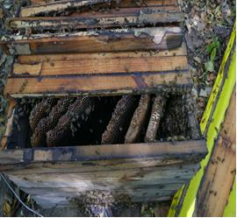
To mitigate these effects (Fig 5.3), beekeepers should ensure that wax is applied evenly and smoothly to the top bars of hive frames. This may involve using techniques such as dipping or brushing melted beeswax onto the bars or using pre-made wax foundation sheets. Regular hive inspections can help identify any issues with comb construction early on, allowing beekeepers to take corrective action as needed.

Fig 5.3: Wrongly applied wax result in bees making combs across or uneven combs

Capturing a Swarm of Bees
In instances where bees do not naturally occupy a hive, they must be manually moved into it. Bees readily inhabit hives during swarming, a process in which they establish a new colony. Swarming occurs for various reasons: overcrowding before the honey season, hive destruction, scarcity of food or water sources, sudden queen failure to lay eggs, excessive heat or poor ventilation in the hive, and insufficient space for egg-laying and honey storage.
Swarm clusters may be found hanging from trees or beneath building overhangs. Once a swarm is located, prompt action is essential. The swarm should be captured swiftly and transferred into a hive. This is typically achieved by brushing or shaking the bees into a basket, empty calabash, or cardboard box, and then transferring them into the awaiting new hive.

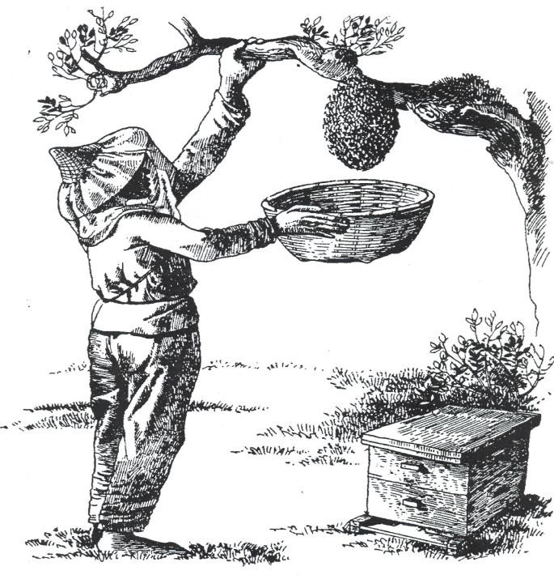
A beekeeper capturing the swarm wearing protective clothing. After capturing, the swarm can be transferred into the beehive

Fig 5.4: Capturing swarm of Bees
In a swarm, bees typically refrain from stinging unless forcibly provoked. However, for safe transfer, it is crucial to never brush the bees without first using smoke and to have a veil and smoker readily available. Once the swarm has been captured, it should be gently shaken into the new hive and left undisturbed for a few days. During this period, the bees will settle into their new home, begin storing food, and care for their young. The optimal time for transferring bees is during the honey season, also known as the swarming season. This typically occurs immediately after the dry spell following the rainy season (likely between February and May) and during the spring months (August to November).

Colony inspection
The ideal time for inspecting the colony is on a bright, sunny day when the bees are actively working. It's important to avoid disturbing the bees during cold, rainy, or windy weather, as well as at night.
When conducting the inspection, start by lighting the smoker and approaching the hive from the side to prevent blocking the bees' entrance. Apply a bit of smoke to the entrance holes, focusing on the busiest areas. Lift the lid and gently smoke the surface before replacing the lid, which should then be turned upside down after a brief period.
Carefully loosen the top bars with a knife and remove them one by one for examination, handling them vertically to prevent damage to the combs. Throughout the inspection, maintain awareness of the queen's potential location, ensuring that the top bar where she may reside is returned promptly to avoid disrupting the colony's stability. Handling the top bars with care is crucial, as any harm to the queen could severely impact the colony's survival. Be mindful not to crush any bees, and use smoke judiciously after inspecting each top bar to keep the bees calm.
Once the inspection of the top bars is complete, reassemble all hive components in their original positions to maintain the integrity of the brood nest structure. Movable top bars facilitate the inspection process, allowing each comb to be lifted and examined thoroughly. Throughout the inspection, it's essential to remove any pests or insects encountered within the hive.
Other Apiary management practices
Providing Water for Bees: During the months of August to October, many rivers and streams dry up, posing a challenge for bees to find water. Water is crucial for bees; they may even prioritize water collection over nectar gathering. In hot weather, bees use water to regulate the hive temperature, ensuring it stays around 35 degrees Celsius. Farmers can support bee colonies by placing old buckets filled with water near apiaries, reducing the bees' need to travel long distances for water. It's important to place leaves or twigs in the water to provide landing spots and prevent drowning. Additionally, ensure that water sources are shaded to keep them cool, as bees may avoid drinking hot water.
Record Keeping: Mentors should maintain detailed records of hive activity, including occupied and unoccupied hives. Any disturbances to the hives, such as damage from vandals or pesticide exposure, should be documented, along with any maintenance or repairs carried out in the apiary. Any hive movements within the same apiary or to different locations should also be recorded, along with the reasons for relocation.
Creating Firebreaks around Apiaries: One of the significant challenges facing natural resource conservation is bushfires, especially during the months of August and September. Communities in rural areas often burn forests during this time, when vegetation is dry and temperatures are high, leading to uncontrollable fires. Bushfires not only contribute to carbon emissions but also degrade forest ecosystems. These fires negatively impact beekeeping as bees rely on flowers during this period to produce honey for the upcoming months. Consequently, honey yields are often lower in December due to the effects of bushfires. Establishing firebreaks around apiaries can help mitigate the risk of fire damage and protect bee habitats, ensuring sustainable beekeeping practices.

SECTION 6: BEEKEEPING FLORAL CALENDAR

6.1 Introduction
Zambia has many thousands of hectares of Brachystegia woodland which provides an excellent source of nectar for bees, so that in most seasons they can be depended upon to give a surplus of honey. The availability of bee forage varies greatly depending on the proportions of the various tree species in the wood lands, on the type of soils, on the quantity of the woodland and on the rainfall.
Over the country as whole, the main tree flowering period is September, October and extending into November, usually before the main rains break, and this flowering period gives a crop of honey in October-November which is usually called the main honey flow. In addition over considerable areas Julbernadia paniculata and Julbernadia globiflora occur and these heavy nectar producers flower from February to May producing a second flow in May and June. In some areas this second flow gives a larger crop than the main flow because the woodland there consists predominantly of Julbernadia species. It must be stressed that the major sources of nectar are the Brachystegia spp and the Julbernadia spp. However, any species which flower out of the main season are important, enabling the bees to keep up their stores of pollen and honey.The most important species in the group are Marquesia macroura, Syzygium spp. And Parinari spp These species flower up to two months before the main honey flow, allowing the bees to build up their numbers with early rapid breeding so that colonies are at peak strength when the main flow starts.
Even in areas where Brachystegia spp. Do not occure, good yields may be obtained from other species such as Acacia and from shrubs and perhaps herbs. Similarly, many agricultural crops e.g. Sunflowers and fruit trees, provide bees with their requirements. The introduction of bees into agricultural areas has the added advantage that the bees assist with the pollination of the farmer’s crops and thus help him to obtain bigger yields.
Eucalyptus plantations are also suitable for bees and the establishment of a Eucalyptus woodlot not only enhances the prospects of good beekeeping, but also provides the farmer with his various wood requirements.
Bees need a variety of nectar-yielding flowering trees, shrubs, crops and annual plants to make honey.

6.2 Literature notes
Bees have their own cycle which they follow every year. Trees flower differently in a year. Bees do not visit all the trees that flowers but there are certain species that are visited at specific times of the day. Some flowers are visited in the morning and others in the afternoon. The bee colony responds very well when they are flowers in the environment. The queen starts to lay more eggs and the population of bees grows during certain period when there plenty of flowers blooming. When there are no flowers, the queen instinctively stops laying the eggs. Therefore it is important for the beekeepers to know when the trees flowers and what time the bees visit these flowers.
The beekeeping floral calendar serves as a valuable tool for beekeepers, providing guidance on the timing and availability of floral resources throughout the year. By understanding the seasonal blooming patterns of different plants, beekeepers can optimize hive management practices, maximize honey production, and support bee health and nutrition.
- Spring:
  - Spring heralds the onset of floral abundance, as temperatures rise and daylight hours increase. Early spring blooms such as fruit trees (e.g., apple, cherry, plum) and willows provide essential nectar and pollen sources for bees emerging from winter dormancy.
  - Beekeepers focus on hive inspections, swarm prevention, and colony buildup during spring, ensuring colonies have access to ample forage resources to fuel brood rearing and population expansion.
- Summer:
  - Summer is a peak foraging season for bees, with a diverse array of flowering plants in bloom. Field crops (e.g., clover, alfalfa, sunflower), wildflowers, and garden plants contribute to a bounty of nectar and pollen.
  - Beekeepers monitor hive productivity, conduct honey harvests, and manage swarming tendencies during summer months. Providing supplemental water sources and shade can help bees cope with hot weather and maintain hive temperature regulation.
- Fall:
  - Fall brings a transition from summer abundance to autumnal blooms, with late-season flowers such as asters, goldenrods, and fall-blooming shrubs providing vital forage for bees preparing for winter.
  - Beekeepers focus on hive preparations for winter, including assessing colony health, reducing hive entrances to deter pests, and ensuring adequate honey stores for overwintering.
- Winter:
    - Winter poses challenges for bees as forage opportunities become scarce and cold temperatures limit foraging activity. In temperate regions, bees may consume stored honey reserves and form winter clusters to conserve heat.
    - Beekeepers employ winterization techniques such as insulating hives, providing supplemental feeding when necessary, and monitoring hive weight to prevent starvation.
    - Some beekeepers in milder climates may have opportunities for early spring foraging if temperatures permit, necessitating vigilance in monitoring hive conditions and resource availability.
The beekeeping floral calendar serves as a seasonal roadmap for beekeepers, guiding management decisions and practices throughout the year. By aligning hive management strategies with the natural rhythms of floral resources, beekeepers can optimize honey production, support bee health, and promote sustainable beekeeping practices. Continued observation and adaptation to local environmental conditions are key to success in beekeeping across diverse landscapes and climates.

6.3 Training plan
- Learning Objectives: by the end of the session, participants must be able to:
  - Identify and explain the 4 beekeeping season in a year
  - Manage their bee families according to the cycle in the year
  - Identify when the bees have honey
  - Observe the flowers in their localities and make bee calendar
- Target Participants: Bee Farmers, mentors, District Management Team (DMT), and individuals
- Suggested number of participants: A maximum of 25 participants
- Duration: 2 hours
- Materials: Flip charts and masking tapes or chalkboard, notebooks and pens, chalk and marker pens, posters, TVs, Projectors, generators, films and photos of flowers visited by the bee, and handouts.
- Methods: Lectures, Brainstorming, Group discussions
Step 1: Write the title “BEEKEEPING FLORAL CALENDAR” on the flip chart or chalk board and introduce it to the participants.
Step 2: Discuss with the participants by brainstorming on the bee seasons in their areas in a year.
Step 3: Organise the participants into 3 groups and give each group the following tasks:
- Group 1: Which plants do bees visit during flowering and when does flowering happen.
- Make the bee floral calendar and show months of honey season
- How do you know that the honey is ready in the hive
Step 4: During plenary, participants present findings, the trainer clarifies, summarizes and gives handouts.

6.4 Handout: Beekeeping floral calendar
Bees experience distinct seasons throughout the year, each closely tied to the prevailing weather conditions. These weather variations exert significant influence on bee hive populations. During periods of abundant food availability, often associated with favorable weather, bee populations soar as the queen intensifies egg laying. Conversely, when food sources dwindle, the queen ceases egg production, leading to a decline in hive population until reaching a minimum level.

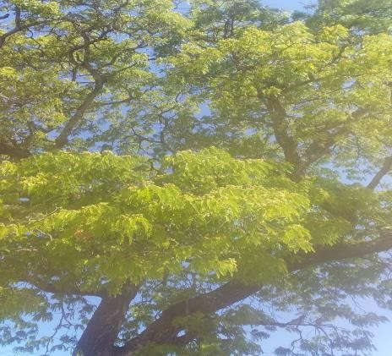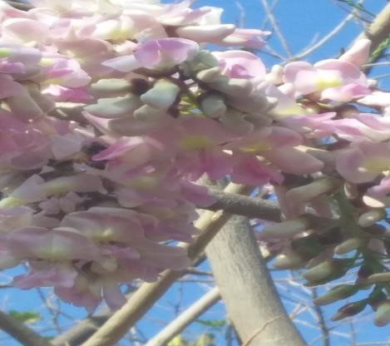
Fig 6.1: Trees flowering to offer nectar for the bees
Similarly, there are specific times when honey can be harvested, while at other times, the hive may yield no honey. Key questions arise regarding the timing of plant flowering, honey production, swarming events, resting periods for bees, and corresponding beekeeping activities:
- What plants flower during particular periods?
- When is the honey production season?
- When does the swarming season typically occur?
- At what times do bees enter their resting phase?
- What tasks should beekeepers undertake as each seasonal transition occurs to effectively manage their hives?
Understanding these seasonal dynamics is essential for beekeepers to optimize hive management, ensure the health and productivity of their bee colonies, and maximize honey production.
The calendar provided outlines the seasonal shifts observed in Eastern Province:
- Build-up Phase or Swarming Season: During this phase, bee populations experience significant growth due to abundant flower availability. With plentiful food sources, the queen bee can lay up to 2000 eggs per day, facilitating rapid colony expansion. This period is characterized by increased swarming activity, presenting an opportunity for farmers to capitalize by baiting hives to capture swarms effectively.
- Honey Season: This season marks the peak of honey production, with hives reaching maximum capacity. Mentors and farmers can readily harvest honey during this time. Indicators of honey-filled hives include increased hive weight, a surge in bee population, and bees congregating near hive entrances due to limited space. Additionally, bees may exhibit defensive behavior, stinging even at a distance of 100 meters from the hive when honey stores are abundant.
- Dearth (Rest) Period: The dearth period signifies a time of scarcity, with minimal floral resources available in the environment. If hives have been excessively harvested, bees may abscond in search of more abundant food sources. Supplementary feeding is recommended during this phase to support colony survival. The dearth period also corresponds to the lowest bee population levels, emphasizing the need for beekeepers to monitor and manage resources carefully.
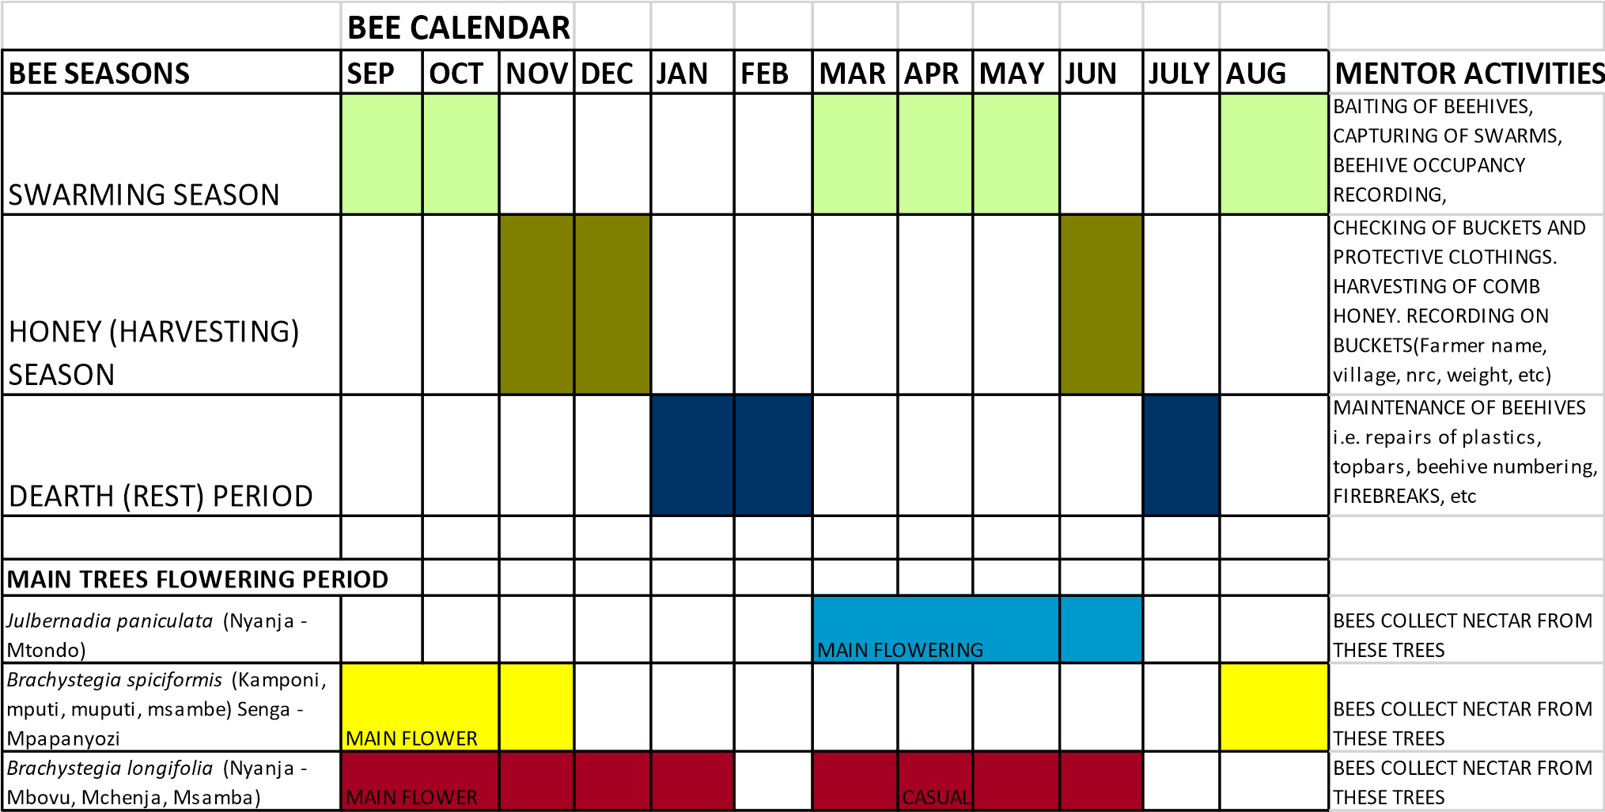
Fig 6.2: Beekeeping calendar
- Dearth Period (Rest) January to Mid-February and July to Mid-August Brood production and honey production drops. Mentor Duties
  - Conduct external inspections of the apiary to monitor for pests such as ants and termites, which are particularly troublesome at this time. Ensure the apiary remains tidy and apply grease or used oil to deter pests.
  - Remove unoccupied combs to prevent wax moth infestations.

- Swarming Season Late February to Mid-May and Late July to October During swarming season, brood production accelerates rapidly, leading to an increase in the bee population.
Mentor Duties
  - Bait and hang bar hives by the end of February or July.
  - Continue baiting and hanging top bar hives in March or September.
  - Regularly check hives for signs of population growth, observe the arrangement of the brood nest, and monitor the amount of pollen and honey stored.

C. Honey Season Late May to Mid-July and November to December
During the honey season, bees collect nectar and convert it into honey, which is then sealed in cells with approximately 18% water content. Mentor Duties
- Conduct crop checks to assess the amount of sealed comb honey, pollen, and brood, as well as the weight of the hive and bee flight activities.
- Begin quality harvesting of honey by removing combs with at least 75% of cells sealed, grading and placing comb honey into clean plastic buckets.
- Avoid over-cropping comb honey to ensure there is enough left for the bees and to prevent them from absconding.
- Transport graded comb honey to the bulking point.
- Implement fire breaks around the apiaries to protect them from potential late fires.

SECTION 8: HARVESTING QUALITY COMB HONEY

7.1 Introduction
The training session on "Harvesting Quality Honey" aim to equip participants with the necessary knowledge and skills to ensure the production of high-quality honey, essential for successful marketing and maintaining consumer satisfaction. The session will delve into various aspects of honey harvesting, grading, and handling, as well as methods for assessing honey quality, particularly focusing on moisture content. By the end of training participants will be empowered to confidently identify, harvest, grade, and handle honey of exceptional quality.

7.2 Literature notes.
Harvesting comb honey is a delicate process that requires careful attention to detail to ensure optimal quality and flavor. Comb honey, prized for its natural presentation and distinct texture, is a favorite among consumers and beekeepers alike. Understanding best practices for harvesting comb honey is essential for maximizing yields, preserving hive integrity, and delivering a premium product to market.
- Timing of Harvest:
  - Timing is critical when harvesting comb honey to ensure proper ripeness and flavor. Comb honey should be harvested when the honey cells are capped with beeswax, indicating that the honey is fully ripened and ready for consumption.
  - Beekeepers monitor hive activity and honey production throughout the season, waiting for the ideal moment to harvest comb honey when honey flow is at its peak and honey cells are sealed.
- Preparation of Equipment:
  - Prior to harvesting comb honey, beekeepers must prepare clean, food-grade containers and equipment to maintain hygiene and prevent contamination.
  - Specialized equipment such as section honey supers or cut-comb frames with foundation are used to encourage bees to construct uniform honeycomb suitable for harvesting.
- Harvesting Technique:
  - When harvesting comb honey, beekeepers gently remove the honey-filled frames or sections from the hive, taking care not to damage the delicate honeycomb.
  - Comb honey can be harvested in various forms, including whole sections of honeycomb, cut comb squares, or individual comb cells, depending on beekeeper preference and market demand.
  - Careful handling and attention to detail are essential to preserve the integrity of the honeycomb and maintain its natural appearance and texture.
- Packaging and Presentation:
  - Once harvested, comb honey is carefully packaged to protect it from damage and maintain freshness. Containers should be clean, airtight, and labeled with relevant product information.
  - Comb honey is often presented in transparent packaging to showcase its natural beauty and attract consumers. Proper labeling should include the honey's origin, floral source, and any relevant production details.
  - Beekeepers may choose to market comb honey alongside liquid honey or other bee products to offer consumers a variety of options and showcase the diversity of their apiary products.
- Storage and Handling:
  - Proper storage and handling practices are essential for preserving the quality and flavor of comb honey. Honeycomb should be stored in a cool, dry place away from direct sunlight and strong odors.
  - Comb honey has a relatively long shelf life when stored correctly, but it is susceptible to crystallization over time. Regular inspection and rotation of inventory can help maintain product freshness and minimize waste.
Harvesting quality comb honey requires patience, skill, and attention to detail. By following best practices for timing, equipment preparation, harvesting technique, packaging, and storage, beekeepers can produce comb honey of exceptional quality that delights consumers and showcases the natural beauty of their apiary products. Continuous improvement and innovation in harvesting methods contribute to the sustainability and success of comb honey production in the beekeeping industry. Whenever comb honey is harvested, quality is paramount for marketing reasons. Marketing of honey demands that the honey is not tainted with smoke, the flavor is natural, the moisture content is below 18%, and harvested honey is graded and of good quality honey.

7.3 Training plan
- Learning objectives: By the end of the session, participants will be able to:
  - Identify, harvest, grade and handle good quality honey
  - Explain the different methods used to check water content in honey
- Target Participants: Bee Farmers, mentors, Extension Service Provider (DMT), and individuals
- Suggested number of participants: A maximum of 30 participants
- Duration: 2 hours
- Materials: Flip charts and masking tapes or chalkboard, notebooks and pens, chalk and marker pens, bee products and flowers, posters, TVs, Projectors, generators, films about bee products and other services, refractometers, bee brush, veils, gloves, clean buckets, overalls, and handouts.
- Methods – Lectures, Brainstorming, Group discussions
Step 1: Write the title “HARVESTING QUALITY HONEY” on the flip chart or chalk board and introduce it to the participants.
Step 2: Help the participants to brainstorm on how is honey is processed by the bees and stored in the combs. Look also at why different honey have different smell or tastes and colors
Step 3: Organise the participants in three groups and give them the following tasks to accomplish
- Group 1: What destroys the good quality of honey?
- Group 2: how would you know that the honey is ready for harvest from the hives?
- Group 3: what should be considered when harvesting honey from the hive?
Step 4: In plenary session, the participants’ present findings, the facilitator clarifies and summarizes, gives out the handouts.
Step 5: Field or practical work for the participants to harvest honey at nearest apiary while following the harvesting procedure in the handouts. Follow the following steps in carrying out the field practical
Field Practical Work Steps:
- Step 1: Gather Necessary Equipment Ensure all participants have access to the required equipment, including veils, gloves, clean buckets, bee brushes, and any other tools outlined in the provided handouts.
- Step 2: Safety Briefing Conduct a brief safety briefing, emphasizing the importance of wearing protective gear and following safety protocols while working with bees.
- Step 3: Visit the Apiary Accompany participants to the nearest apiary, where they will have the opportunity to observe and engage in hands-on honey harvesting.
- Step 4: Hive Inspection Guide participants in inspecting the hives to assess honey readiness. Demonstrate how to identify frames containing capped honey, indicating maturity for harvest.
- Step 5: Preparation for Harvest Demonstrate proper techniques for preparing frames for harvest, including removing bees, brushing excess beeswax, and ensuring cleanliness of equipment.
- Step 6: Harvesting Honey Instruct participants on the careful extraction of honey frames from the hive, emphasizing gentle handling to avoid damage and minimize disruption to the hive.
- Step 7: Extraction Process Demonstrate the extraction process, whether using manual methods or equipment such as honey extractors, ensuring participants understand the importance of maintaining hygiene throughout.
- Step 8: Filtering and Bottling Guide participants through the filtering and bottling process, emphasizing the removal of impurities and proper storage to maintain honey quality.
- Step 9: Cleanup and Hive Care After harvesting, ensure participants clean and sanitize all equipment thoroughly. Additionally, provide guidance on hive care and maintenance to support the health and productivity of bee colonies.
- Step 10: Reflection and Discussion Conclude the practical session with a reflection period, allowing participants to share their experiences, ask questions, and discuss any challenges encountered during the harvesting process.
By following these steps, participants will gain practical experience and confidence in harvesting honey while adhering to established procedures for maintaining quality and hive health.

7.4 Handout: Harvesting of good quality comb honey
Bees collect nectar from the flowers and the nectar from the flowers is about 80% water. The bees have to transform the nectar with high water to 18% of moisture content. This is a lot of work for the bees. The bees evaporate the water from honey by fanning the wings and once the honey has reached the required water content, the bees will seal it. The colour of honey is determined by tree species where the nectar was collected. The smell and flavor of the honey are all determined by the flowers where the bees collected nectar
Honey seasons: In Zambia, we usually have two seasons for harvesting honey:
April/ May/ June and October, November, December seasons.
Harvesting of honey from top bar hives: As a good beekeeper, you must know proper cropping of your crops (honey) so as not to waste. Quality honey begins at harvesting and fetch at high price commercially. To ensure quality, the beekeeper must harvest the honey using plastic containers, smokers, smoking materials, knife, and protective clothings (veil, overall, boot, socks).

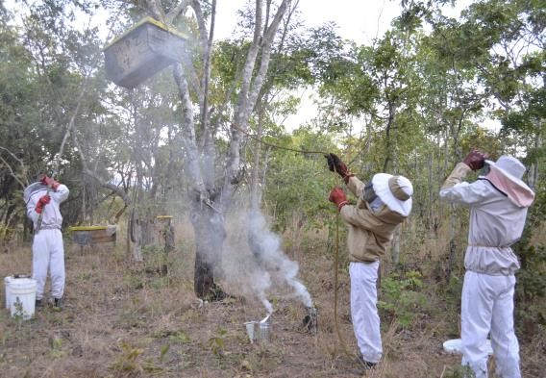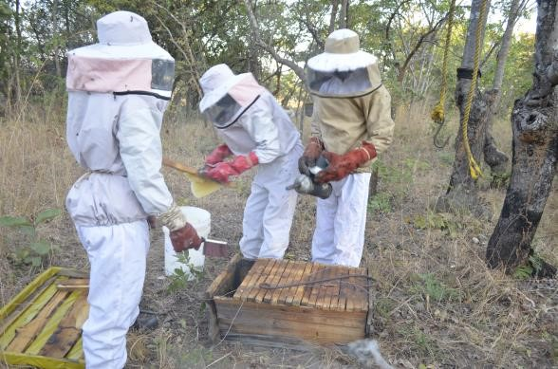
Fig 7.1: When harvesting, bring down the hives so that proper harvesting is done. Always use smoke sparingly. Work with colleagues and share work that can be done: one can handle smoker while the other is cutting the combs and brushing bees off.
It is very important to check the hive before starting harvesting. Only combs that are either fully or half sealed must be harvested. If possible select comb that are sealed with wax, as it does not ferment quickly because it has fully ripened and does not contain any water.
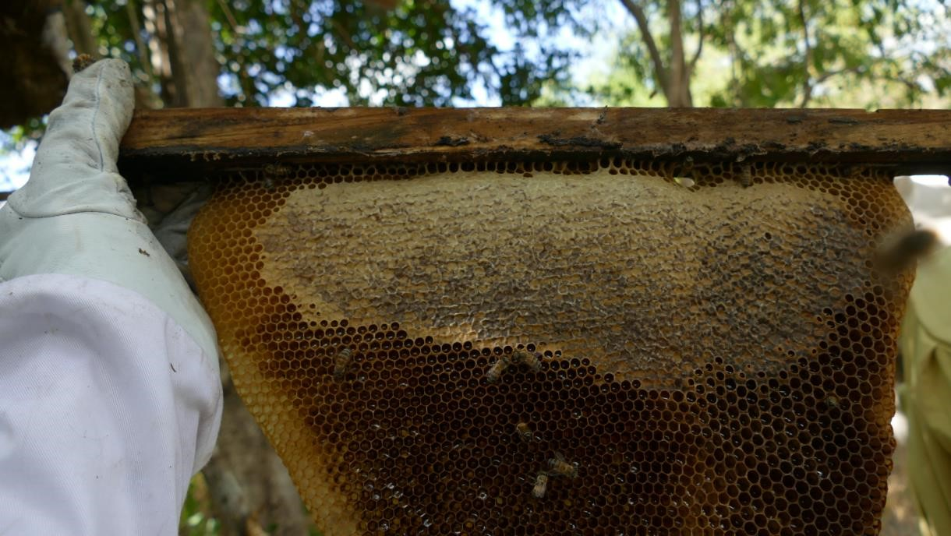
Fig 7.2: In this Photo: The bees have sealed the top part and the rest is nectar which the bees are
working. This comb should not be harvested. Harvest combs with 75% sealed honey. Unsealed
honey contains a lot of water and ferment quickly | .
When harvesting the crops, you must hold the combs vertically so that they are not broken. The top bar must be held over a clean container and cut the entire comb but leaving a 1cm strip, which will serve as an orientation line that bees would be following when making a new comb.
As you harvest the combs, remove the propolis on the sides of top bars before placing them back. Propolis is highly needed for future baiting (planting) of hives and must be stored safely. Continue cropping ripe honey till you notice a large portion of pollen. This large portion is cut off and put it in a second grade container. It is a sign that the brood nest is near. Do not harvest a brood comb even it contains a lot of honey as this affect the labour force in the hive.
You should not overcrop as bees may swarm. Please leave at least 8 combs that will serve as food for bees during the season that have no nectar.
Put the combs with unripe honey immediately behind the last brood or pollen comb and then the harvested top bars outside. This allows easier movements of the queen and easier building up of combs from the central part.
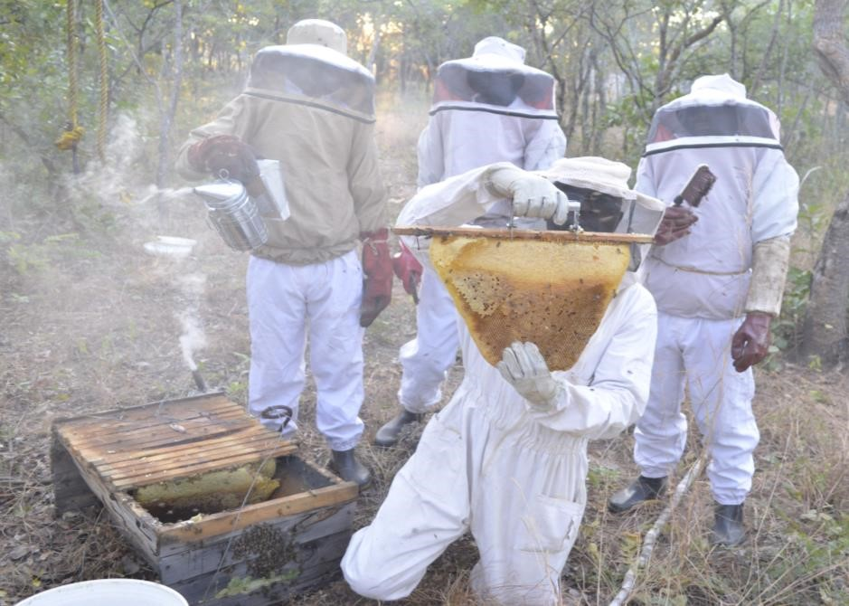
Fig 7.3: Harvest during the day so that you are able to see the comb clearly.
Grading of comb honey: Immediately, after cropping you have to grade your comb honey before the combs get broken in the cropping container. Select all the combs which are light in colour and which have mostly sealed honey. Pick off any bees and any dirt, and put the combs into the first grade container.

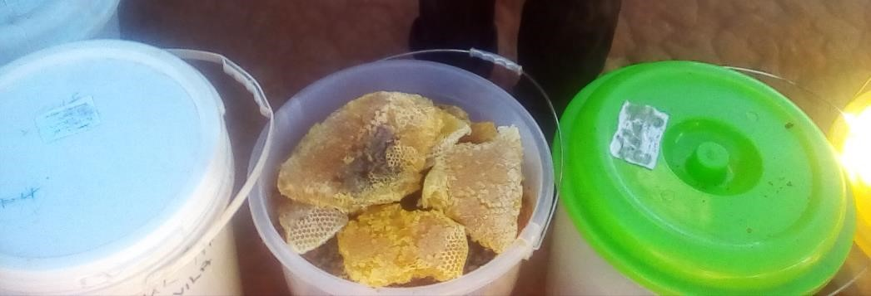
Fig 7.4: White combs is a sign that the comb were made recently
All the very dark combs and combs containing plenty of pollen cells or unsealed honey have to be put into a separate container. The container with the first grade must be closed tightly to avoid moisture absorption as honey is hygroscopic.
Difference between the high grade honey and low grade honey: Comb honey can easily be distinguished just by observation. The low-grade honey contains pollen and is darkish, yellowish and thickish while combs, which are white or light in colour, or mostly sealed with honey is the first grade.
For quality honey it has to be separated when cropping before they got broken in the cropping container. The honey must not be smoked after cropping otherwise it may be contaminated with smoke.
Do not expose honey to water, rain, sun, heat, etc. Remove all impurities like dead bees, grass, or foreign materials. Do not crop during rainy weather. The honey draws moisture from the air and gets watery.

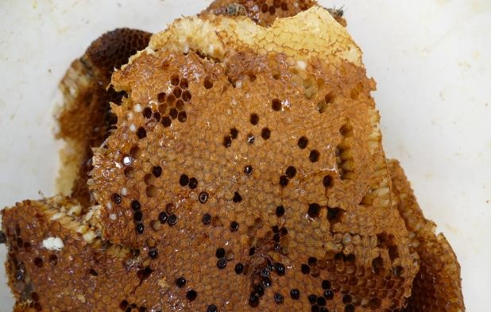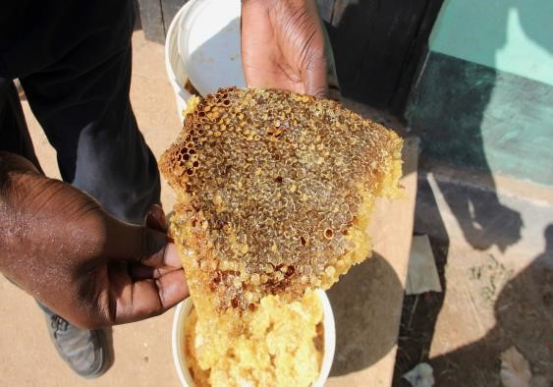

Fig 7.5: This is the difference between the sealed combs for honey and sealed comb for pupae or brood. The cell that seal the brood is dark brown and porous so that beehive air can pass through to the brood (Left photo). (Right Photo) The cell that seal honey is creamy white and no air can go through and not further moisture can be absorbed.

Harvesting method with Beekeeping Mentor system
For purchases made by COMACO, honey harvesting follows a structured process to ensure quality control and fair compensation for farmers. Here's an outline of the steps involved:
Harvesting Process:
- Team Formation: Mentors organize harvesting teams consisting of two or three individuals, including themselves, an assistant, and a farmer. Each team is equipped with protective gear, smokers, buckets, pulleys, and ropes.
- Harvesting and Grading: Teams remove combs from hives, grade them, and place them in plastic containers with tight lids to prevent moisture absorption and contamination. After harvesting, hive lids are replaced, and hives are left in good condition.
- Weighing and Recording: Comb honey in plastic containers is immediately weighed, and details are recorded in the payment register. Farmers sign the register to acknowledge the amount due to them.
- Transportation to Bulking Point: Farmers transport the comb honey to the designated Bulking Point for storage.
- Payment and Collection: Once all hives are harvested, the mentor notifies the Beekeeping Officer to arrange for payment and honey collection on a specified date.
Commission Structure:
- Mentors receive a 10% commission from honey yields, with an additional 10% distributed to harvesting teams, totaling a 20% commission for every kilogram of honey harvested.
- For example, if a mentor harvests 500kg of honey at a price of K14.5 per kg, they receive K750 as commission, while the harvesting team also receives K750.
Honey Collection Procedure:
- Comb honey is bulked at designated points, overseen by beekeeping specialists, mentors, and senior lead farmers acting as focal persons. Mentors are responsible for bucket safekeeping and grading.
- When honey accumulation reaches a critical mass (e.g., 700kg), the mentor sends a bulking amount SMS to the server, and arrangements are made for cash payment during honey uplifting.
- A qualified grader accompanies the vehicle collecting honey, ensuring buckets are inspected for quality, properly sealed, and labeled with farmer details for traceability.
- During transportation, care is taken to avoid over-tightening ropes around buckets and over-stacking, minimizing the risk of breakage and ensuring honey quality is maintained throughout the process.

SECTION 8: BEEKEEPING EQUIPMENTS

8.1 Introduction
This training session on "Beekeeping Equipment." will explore the essential protective gear necessary for successful beekeeping and the importance of wearing it to ensure the safety and well-being of beekeepers. At the end of the training, participants will have a comprehensive understanding of the various types of protective clothing used in beekeeping and their significance in protecting against bee stings and other potential hazards. Through interactive discussions and practical demonstrations, we aim to equip participants with the knowledge and skills needed to work confidently with bees while minimizing risks.

8.2 Literature notes
Beekeeping equipment is essential for managing honeybee colonies effectively and ensuring the health and productivity of bee colonies. From hive components to protective gear, the right equipment enables beekeepers to perform hive inspections, harvest honey, and protect themselves from bee stings. Understanding the different types of beekeeping equipment and their functions is crucial for novice and experienced beekeepers alike.
- Hive Components:
  - Hive bodies: Also known as supers, hive bodies are stackable wooden boxes that house bee colonies. They contain frames where bees build honeycomb and rear brood.
  - Frames: Frames provide structural support for honeycomb and brood comb. They can be either wooden or plastic and come in various sizes to accommodate different hive configurations.
  - Foundation: Foundation sheets or frames provide a template for bees to build comb. They can be made of beeswax or plastic and may be either pre-printed with hexagonal cells or left blank for bees to draw comb naturally.
- Protective Gear:
  - Bee suit: A full-body garment made of lightweight, breathable fabric that covers the beekeeper from head to toe, providing protection against bee stings.
  - Veil: A mesh or transparent fabric hood that attaches to the beekeeper's hat or suit to protect the face and neck from bee stings while maintaining visibility.
  - Gloves: Leather or canvas gloves with gauntlets that cover the hands and wrists, providing protection against bee stings during hive inspections and honey harvesting.
- Tools and Accessories:
  - Smoker: A device used to produce cool smoke that calms bees during hive inspections. Smokers contain fuel (e.g., wood chips, pine needles) that smolder and release smoke when ignited.
  - Hive tool: A multipurpose tool with a flat blade and hook designed for prying apart hive components, scraping propolis and wax, and manipulating frames during inspections.
  - Bee brush: A soft-bristled brush used to gently remove bees from frames, hive components, or the beekeeper's clothing without harming them.
  - Extractor: A mechanical device used to extract honey from honeycomb. Extractors spin frames at high speeds, causing honey to be flung out of the comb and collected in a reservoir.
- Feeding and Medication:
  - Feeders: Various types of feeders, such as top feeders, frame feeders, and entrance feeders, are used to provide supplemental food (e.g., sugar syrup) to bees during times of nectar dearth or colony buildup.
  - Medications and treatments: Beekeepers may use medications, supplements, or treatments to manage pests, diseases, or nutritional deficiencies in bee colonies. These may include miticides, antibiotics, essential oils, or pollen supplements.
Beekeeping equipment encompasses a diverse range of tools, garments, and accessories designed to facilitate hive management, honey harvesting, and beekeeper safety. By selecting high-quality equipment appropriate for their needs and maintaining it regularly, beekeepers can ensure the success and sustainability of their beekeeping operations while promoting the health and well-being of honeybee colonies.

8.3 Training plan
- Learning objectives: By the end of the session, participants will be able to:
  - Know the types of protective clothing that are used by the beekeeper
  - Explain the different ways the protective clothings protect the beekeeper
- Target Participants: Bee Farmers, mentors, Extension Service Provider (DMT), and individuals
- Suggested number of participants: A maximum of 30 participants
- Duration: 2 hours
- Materials: Flip charts and masking tapes or chalkboard, notebooks and pens, chalk and marker pens, bee products and flowers, posters, TVs, Projectors, generators, films about bee products and other services, and handouts, bee brush, veils, gloves, overalls, gum boots and veils
- Methods: Lectures, Brainstorming and Group discussions
Step 1: Write the title “BEEKEEPING EQUIPMENTS” on the flip chart or chalk board and introduce it to the participants.
Step 2: Brainstorm with the community to think through what each protective clothing helps to the protect the body of the beekeeper and what will happen if the farmers do not wear the protective clothings
Step 3: Organise the participants in two groups and give the following tasks to accomplish
- Group 1: List the protective clothing and its use?
- Group 2: Demonstrate their use and which one is more essential of the whole protective clothing?
Step 4: In plenary session, the participants to present findings, the facilitator clarifies and summarises, gives out the handouts.

8.4 Handout: Beekeeping equipment
For Beekeeping to be successful, the mentor and farmer will need following necessary equipment in order to work with the bees confidently.
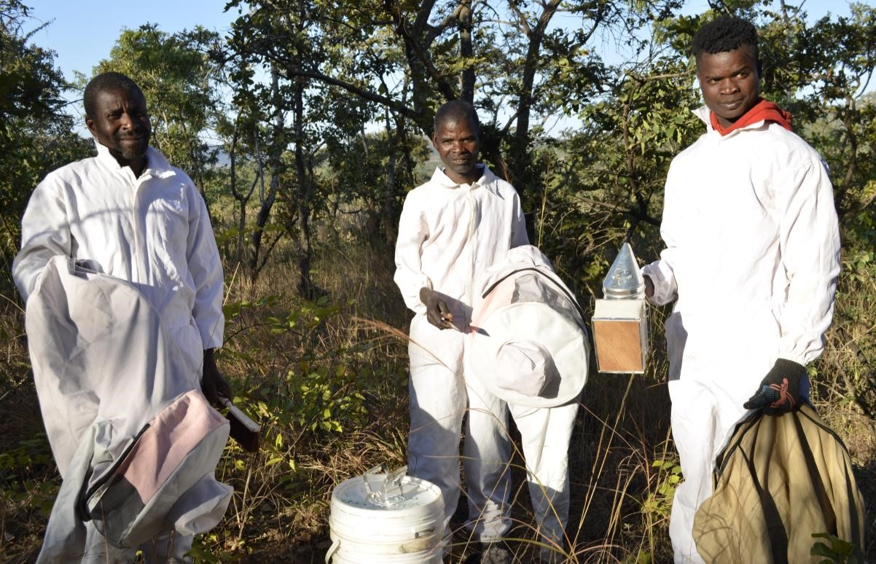
Protective clothings for
beekeeping, i.e. veil, hive
tool, bee brush, smoker,
overall, & gloves

8.1: Beekeeping protective gear
Veil: This is basically a cylinder made of net is used to keep aggressive bees away from the face and eyes. The face is the most sensitive part of the body in terms of swelling.
Overalls: Preferably white in colour should be worn to provide body protection. White is preferred because it reflect light and able to keep the body temperature low. The only problem is how to keep it clean therefore the mentors/ farmers must always wary of black soil and dirt around to keep them clean. Other colours can be used except black. Of all the colors’, bees tend to sting more when you are wearing black.
Gloves and gum boots: These are to protect the hands and feet from bee stings and other external injuries that may occur while working with bees. They must be made from soft leather or canvas type cloth
Hive tool /knife: This helps to loosen the top bars which have been glued together by the bees. A piece of hard metal, crowbar like, bent at one end and sharp at the other end will do. You can also use the knife to cut combs during harvesting.
Bee brush: It is used to sweep the bees from the combs. The key word is “sweep” when using the brush and not digs into the comb. You can use a small, oblong brush, strong feather or the whole wing of a bird.
Smoker: This is the most valuable tool for working with the bees. It is used to distract the bees. When worker bees smell smoke, they fill themselves with honey. It is difficult for a bee with a full stomach to sting because it cannot double up.
The best material for use in smokers is old, dry sacking or rotten wood, since these burn slowly and give off cool smoke. Rags, cotton waste, wood shavings, cow dung, elephant dung (generally herbivore dung), dried corn cobs, and dry leaves also make good fuel for the smoker. When choosing best material to use for smoking, as a mentor or farmer should look for the smoking material that will last long and produces a good smoke.
When lighting the smoker, some mentors and farmers start with fire below and then add for example cow dung on top but other would rather put fire on top of cow dung. Both methods work and a mentor/ farmer can choose the method he/ she prefers.
To avoid over smoking honey, mentors are advised to smoke the hive horizontally. This means the smoker is kept outside and smoke should be moving horizontally with the top bars so that the bees remain inside the hive. Most mentors prefers putting the mouth of the smoker inside the hives and pumps a lot of smoke into the hive. This is not good practice as the smoke contaminates honey. The ashes from the smoker can also fall on the combs contaminating it. The heat can also kill the bees or accidentally kill the queen.

SECTION 9: BEE PESTS, PREDATORS AND DISEASES

9.1 Introduction
This training session is designed to equip bee farmers, mentors, extension service providers, and interested individuals with the necessary knowledge and skills to effectively manage bee colonies and optimize honey production. During this training program, we will delve into various aspects that affect bee health and honey yield. Understanding the challenges posed by both human activities and natural factors is essential for successful beekeeping practices, and we will explore strategies to mitigate these impacts. This journey is exciting with valuable insights and practical techniques that will enhance one’s beekeeping endeavors.

9.2 Literature notes
Beekeeping and honey production are vital components of agricultural ecosystems, providing essential pollination services and valuable honey products. However, beekeepers face numerous challenges stemming from pests, predators, and diseases that can significantly impact bee health and honey yields. Understanding these threats is essential for effective beekeeping management and ensuring the sustainability of bee populations and honey production.
- Bee Pests:
  - Varroa destructor: Varroa mites are one of the most devastating pests affecting honeybee colonies worldwide. These external parasites feed on the bodily fluids of adult bees and brood, weakening the colony and transmitting viruses.
  - Small Hive Beetle (Aethina tumida): Small hive beetles infest beehives, consuming pollen, honey, and bee brood. They can cause significant damage to honeycomb and hive structures, leading to colony collapse.
  - Wax Moth (Galleria mellonella and Achroia grisella): Wax moths infest beehives, laying eggs on beeswax and honeycomb. Larvae consume beeswax and debris, compromising hive integrity and hygiene.
- Predators:
  - Bears: In regions inhabited by bears, beehives are vulnerable to attacks as bears seek honey as a food source. Beekeepers must implement bear-proofing measures to protect their colonies.
  - Ants: Ants can infiltrate beehives, scavenging honey and preying on bee brood. Their presence can disrupt hive activity and weaken bee colonies if left unaddressed.
- Diseases:
  - Nosema spp.: Nosema is a fungal disease that affects the digestive tracts of bees, leading to reduced lifespan and weakened immune systems. Severe infestations can result in colony collapse.
  - American Foulbrood (Paenibacillus larvae): American foulbrood is a bacterial disease that primarily affects bee larvae. It spreads rapidly within hives, leading to the decay of brood and eventual hive death if not treated promptly.
  - European Foulbrood (Melissococcus plutonius): Similar to American foulbrood, European foulbrood is a bacterial disease that affects bee larvae, causing brood decay and colony decline. It poses a significant threat to honeybee colonies.
Therefore, beekeeping and honey production are susceptible to various challenges posed by pests, predators, and diseases. Effective management strategies, including pest monitoring, hive maintenance, and disease prevention measures, are essential for mitigating these threats and ensuring the health and productivity of bee colonies. Continued research and education are critical for developing sustainable beekeeping practices that support thriving bee populations and robust honey production industries.

9.3 Training plan
- Learning objectives: By the end of the session, the participants must be able to:
  - Identify different pests and predators relevant to beekeeping.
  - Explain how human and natural activities can affect beekeeping.
  - Describe various methods to control pests, predators, and other issues affecting beekeeping.
- Target Participants: Bee Farmers, mentors, Extension Service Provider (DMT), and individuals.
- Suggested number of participants: A maximum of 30 participants
- Duration: 2 hours
- Materials: Flip charts and masking tapes or chalkboard, notebooks and pens, chalk and marker pens, posters, TVs, Projectors, generators, films about diseases and handouts.
- Methods: Lectures, Brainstorming and Group discussions
Step 1: Write the title “Problems/ Bee Pests and Diseases affecting beekeeping and honey production” on the flip chart or chalk board and introduce it to the participants.
Step 2: Engage every participants to give examples of any pest he/ she knows in their area and the control
Step 3: Guide the participants in describing the common bee diseases affecting bees and their control

9.4 Handout: Bee Pests, Predators and Diseases
The following are the examples of bee pests and predators:
- Ants including red/ safari ants
- Honey badgers
- Wax moth
- Man
- Spiders
- Hive beetles
- Mice
- Mould and fungus
- Pesticides
- Termites
- Cattle
- Robber bees
- Lizards
Human activities
Humans are a biggest problem to bees because they cause fire which can burn the hive and destroys the trees where bees collect flowers. Theft of honey is also done by humans and vandalism of hives. Humans also spray pesticides on their crops that kill the bees. Mentors/ farmers must sensitize farmers on the importance of bees and forests.
Natural activities
All the beehives should not be placed where it is open with no wind breaks as the hive can be swinging by strong wind hence breaking the wire. Hives must not be placed in water logged areas as the honey may not mature quickly.
Absconding of bees
African Bees abscond for many reasons from the hive. It can be due to overharvesting or starvation if there are no flowers around the area. If the roof or plastic is leaking with water, bees can abscond. To prevent absconding, ensure that the hive has less dark combs, the hive has enough food and there is no disturbance to the hives like fire or people.
Poor management of colonies
Honey production in the hive can be affected if the farmers or the mentors do not visit the apiary. It is important to check regularly the wires of the hives, damages to the hives and routine maintenance should be done to the hive. At the time of harvesting, the hive should not be over harvested to avoid affecting the food reserve for the bees.

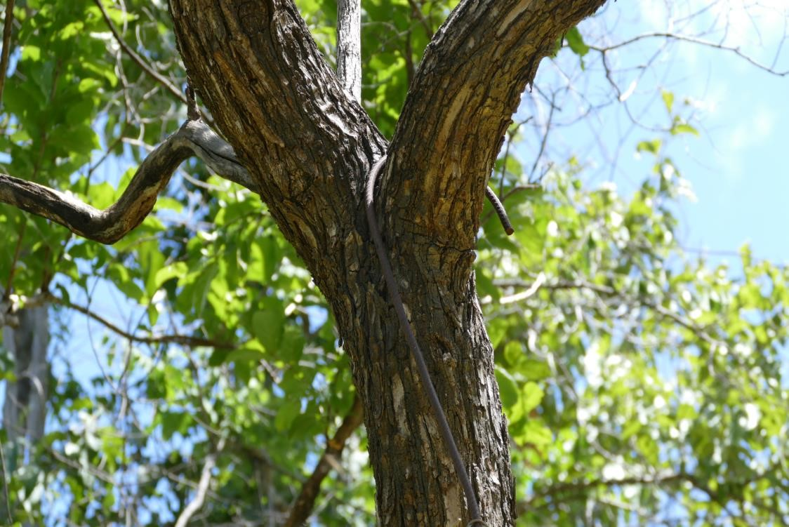
Fig 9.1 do not hang hive like this because it becomes difficult to bring it down. (Second Photo) The comb formed across making difficult to harvest or inspect the hive. Always make good wax
foundation which the bees can easily follow.

COMMON PESTS AND DISEASES IN ZAMBIA
PEST | PHOTO | IMPACT | CONTROL MEASURE
Ants (Red ants):  Ants are a big problem for bees especially in rain seasons. The ants move in huge colonies and can encircle the hive entrance and enter the hive. The nest of ant is usually around the apiary and we do not recommend burning the nest. Other control measures should apply.  Ordinary ants which have local names also attack the bee colony to feed on honey. | 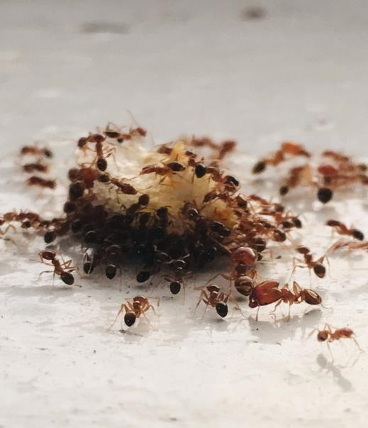 | - The ants attack the colony to kill the bees and eat the honey.  - The worker bees fails to provide defense and the colony is overtaken. The bees abscond.  - A strong colony is able to defend itself from these ordinary ants with no  difficulties | - hives should be suspended by wires  - Hives must not touch or lean to trees.  - Use used oil which is cheap and available on the part where the hook passes the branch.  - You can immerse a cloth and place it under hook so that scent can last long to repel the ants.  - No undergrowth weed or shrubs must reach the hives as they can act as bridges for the ants to reach the hives.  - Keep the apiary tidy especially under the hive  - Spread ash underneath the apiary to keep away ants.  - Avoid hanging hives in damp places like dambos

Honey badger can be problematic in some areas. We do not recommend trapping it or killing it to solve the problem. |  | o  o o | Destroys the hive entrance. It eats the bees, brood, and honey. The colony collapses and the bees abscond  It leaves a strong odour in the hive and must be rebaited for  reoccupation by bees | •  • | Suspend the hive above 3m with wire  Avoid setting up apiaries in areas where there are honey badger.
Wax moth (Galleria  Mellonella)  This is a pest that destroys honey combs in the hive. The wax moth burrows in the combs and create tunnels in the combs. | 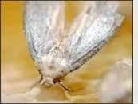 | o  o | It feeds on wax and attacks a week colony which is unable to patrol all the combs.  Dark combs which contains remains of cocoons (remains after bee hatch) represent food with wax moth  larvae | • | A strong colony is able to defend itself from the wax moth and farmers can help by removing unattended combs during the rest period or when the colony is weak.

Small Hive Beetle  This is the insect we have to learn to live with as beekeepers and we have to learn how to manage it. | 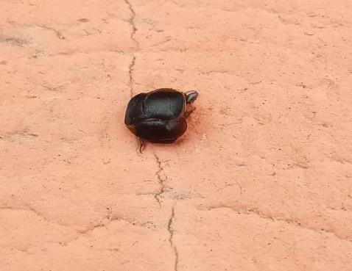 | o o  o | It eats honey and pollen  It causes minimum disturbances to the  colony  It has a giant armour body and the bees fail to sting it. It feeds on nectar in the hive | •  • | A strong colony is able to defend itself by throwing the beetles outside. The hygienic behaviour of bees work wonders  The area where the beehives are hanged should not have a lot of mud.
 |  |  |  | • | Seal all the cracks. Remove combs where the bees do not cover.
 |  |  |  | • | Be clean in the hives and do not give the bees food or syrup that ferment quickly
Large Hive Beetle (Similar to small hive beetle but it is bigger) |  | o o | It blocks the entrance of the hive  Eats honey and induces the bees to feed it | •  • | Reduce the entrance of the hives  Remove the beetles from  the floor of the hive
 |  |  |  | • | You can move the hive to place with more sun if the beetles are problem because the branches are providing too much shade and humidity condition or mud soil could be fertile ground for the beetles.

Bee wasp and bee  pirates  While honey bees can attack when provoked, wasps are naturally  aggressive | 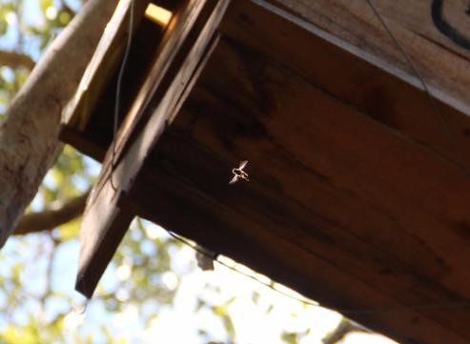 | - Attack and eats the bees as they return to the hives from collecting water and nectar  - They kill less bees and no impact on a strong colony  - May kill queen when it is on return trip from the mating flight  - Sometimes very few bees will venture out of the bees if they  sense danger | • | Avoid setting apiaries where there are a lot of wasps and bee pirates
Snakes | 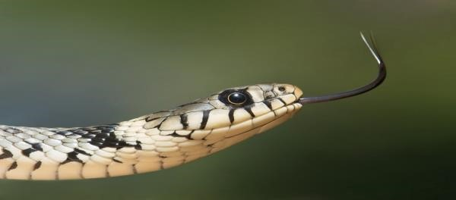 | The snakes normally occupy the unoccupied or empty hives. They also make holes in the comb and stay at the fringe of the hive. The snake make the colony weak. They also pose a big risk to the bee farmer and may avoid harvesting the hive. | • | Reduce the size of the hive entrance.
BEE DISEASES | PHOTO | IMPACT |  | CONTROL MEASURE

American Foul  Brood (AFB)  This bacterium cause bees to die in the larvae or pupa stage.  It is very serious and contagious.  Cappings are indented, the sealed brood becomes sunken and it looks like there is glue in the cells | 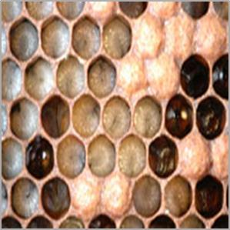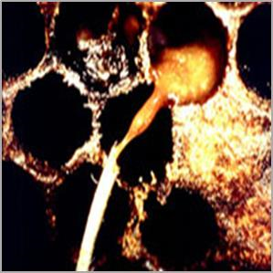 | o o o o o | Coffee-colored, ropey with fine thread of 2.5cm  Odour: sulphorus  “chicken house”  Scale: brown to black,  britlle  Stage of brood attacked: capped  Appearance: chocolate brown to black.  Perforated cappings | •  •  •  •  • | This is a very serious disease and the veterinary Office must be informed urgently so that all the hives are isolated to avoid infecting nearby apiaries. Dig a hole and burn all the bees and the top bars. The hives must be scorched and washed thoroughly  Do not feed honey or exchange the top bars and combs  Do not import bees into Zambia.
European Foul  Brood (EFB)  -This bacterium affects unsealed  larvae  -Larvae dies and  “melt down” in cells | 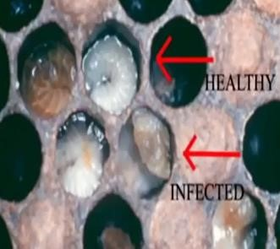 | o  - o  - o | Can be slightly rope threads of less of 1.5cm usually not so ropey Odour: sour or none Scale: brown to black, rubbery  Stage of brood: unsealed Appearance: twisted, dull to yellow to dark brown. Tracheal tubes often  visible | •  • | Combs are removed and new combs are added from unaffected colonies  The queen is caged for a few days so that the workers can remove diseased larvae and then released
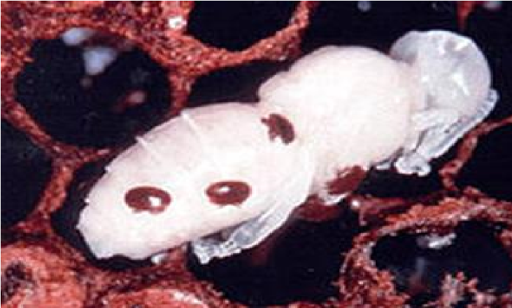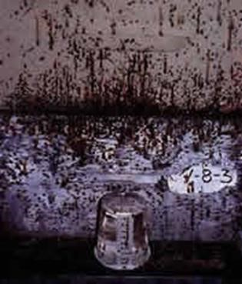
Varroa Mite: it is a
flat, reddish brown
mite

and is relative
of the spider with 8
legs (4 pairs). This
mi
te feeds on the
bees’

blood making
the bee weaker and
weaker
.

Varroa

mites on pupa

o

It is mainly found on the
developing
drone

bee
pupae and emerges with
adult bee

o

It causes deformity

on
bees and slowly kills the
colony

•

DO NOT IMPORT BEES INTO
ZAMBIA to avoid the spread
of v
arroa mites and other
pests.

NOSEMA

This is a disease of
adult
that
bees
causes
poor brood
nest
development
and is accompanied
by diarrhea

o

You will often see yellow
diarrhea outside and at
the entrance of hive

•

It has to be detected by
tre
and
microscope
ated
with medicines

•

Good beekeeping practices
can prevent nosema

•

factors
as
such
Stress
damp apiary sites, lack of
nutrients and lack of space
or infection with any other
disease can contribute to
nosema outbreaks.

Recommended Readings:

CTA (2012). Beekeeping, The Tropical Agriculturis. Macmillan Education-Oxford ,England

Kasisi Agricultural Training (2010). Beekeeping Manual for Small Scale Farmers. Mujalo Printers-Lusaka.

Recommended readings

